


Prepare and display sugar work
D1.HPA.CL4.03
Trainee Manual

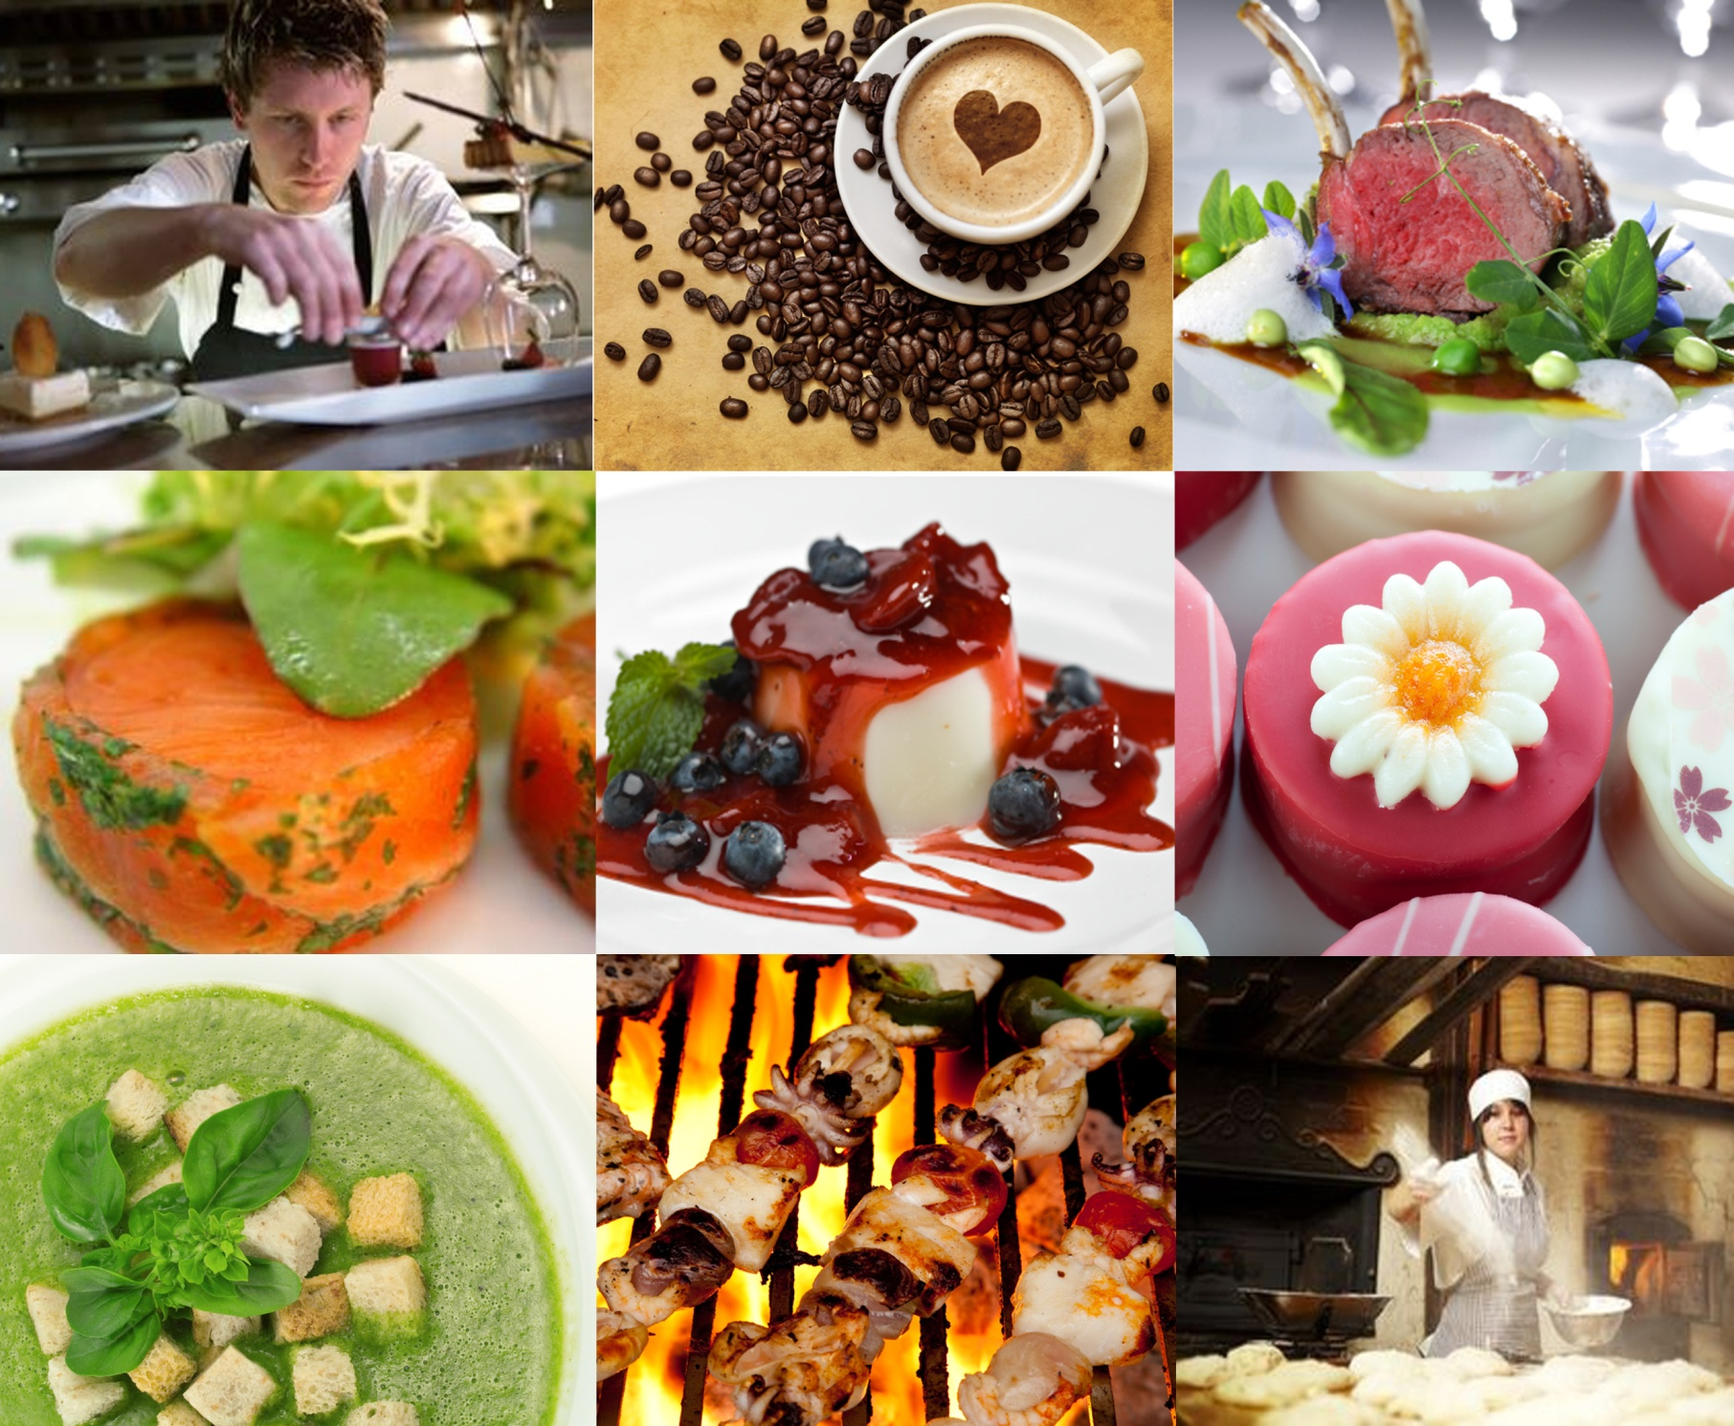




Prepare and display sugar work

D1.HPA.CL4.03

Trainee Manual





Project Base
William Angliss Institute of TAFE
555 La Trobe Street
Melbourne 3000 Victoria
Telephone: | (03) 9606 2111
Facsimile: | (03) 9670 1330
Acknowledgements
Project Director: | Wayne Crosbie
Chief Writer: | Alan Hickman
Subject Writer: | Garry Blackburn
Project Manager: | Alan Maguire
Editor: | Jim Irwin
DTP/Production: | Daniel Chee, Mai Vu, Kaly Quach
The Association of Southeast Asian Nations (ASEAN) was established on 8 August 1967. The Member States of the Association are Brunei Darussalam, Cambodia, Indonesia, Lao PDR, Malaysia, Myanmar, Philippines, Singapore, Thailand and Viet Nam.
The ASEAN Secretariat is based in Jakarta, Indonesia.
General Information on ASEAN appears online at the ASEAN Website: www.asean.org.
All text is produced by William Angliss Institute of TAFE for the ASEAN Project on “Toolbox Development for Front Office, Food and Beverage Services and Food Production Divisions”.
This publication is supported by the Australian Government’s aid program through the ASEAN-Australia Development Cooperation Program Phase II (AADCP II).
Copyright: Association of Southeast Asian Nations (ASEAN) 2013.
All rights reserved.
Disclaimer
Every effort has been made to ensure that this publication is free from errors or omissions. However, you should conduct your own enquiries and seek professional advice before relying on any fact, statement or matter contained in this book. The ASEAN Secretariat and William Angliss Institute of TAFE are not responsible for any injury, loss or damage as a result of material included or omitted from this course. Information in this module is current at the time of publication. Time of publication is indicated in the date stamp at the bottom of each page.
Some images appearing in this resource have been purchased from stock photography suppliers Shutterstock and iStockphoto and other third party copyright owners and as such are non-transferable and non-exclusive. Clip arts, font images and illustrations used are from the Microsoft Office Clip Art and Media Library. Some images have been provided by and are the property of William Angliss Institute.
Additional images have been sourced from Flickr and SKC and are used under Creative Commons licence: http://creativecommons.org/licenses/by/2.0/deed.en
File name: TM_Prepare_&_display_sugar_work_FN_030214





Table of contents
Introduction to trainee manual 1
Unit descriptor 3
Assessment matrix 5
Glossary 7
Element 1: Prepare sugar for boiling 9
Element 2: Boil sugar 21
Element 3: Pull boiled sugar 29
Element 4: Use pulled sugar to produce display sugar work 37
Element 5: Pour boiled sugar to produce cast display sugar work 47
Element 6: Plan sugar display piece 55
Element 7: Assemble and display sugar work piece 61
Element 8: Store sugar display pieces 67
Presentation of written work 71
Recommended reading 73
Equipment that may be required 75
Trainee evaluation sheet 77
Trainee Self-Assessment Checklist 79

Introduction to trainee manual

To the Trainee
Congratulations on joining this course. This Trainee Manual is one part of a ‘toolbox’ which is a resource provided to trainees, trainers and assessors to help you become competent in various areas of your work.
The ‘toolbox’ consists of three elements:
- A Trainee Manual for you to read and study at home or in class
- A Trainer Guide with Power Point slides to help your Trainer explain the content of the training material and provide class activities to help with practice
- An Assessment Manual which provides your Assessor with oral and written questions and other assessment tasks to establish whether or not you have achieved competency.
The first thing you may notice is that this training program and the information you find in the Trainee Manual seems different to the textbooks you have used previously. This is because the method of instruction and examination is different. The method used is called Competency based training (CBT) and Competency based assessment (CBA). CBT and CBA is the training and assessment system chosen by ASEAN (Association of South-East Asian Nations) to train people to work in the tourism and hospitality industry throughout all the ASEAN member states.
What is the CBT and CBA system and why has it been adopted by ASEAN?
CBT is a way of training that concentrates on what a worker can do or is required to do at work. The aim is of the training is to enable trainees to perform tasks and duties at a standard expected by employers. CBT seeks to develop the skills, knowledge and attitudes (or recognise the ones the trainee already possesses) to achieve the required competency standard. ASEAN has adopted the CBT/CBA training system as it is able to produce the type of worker that industry is looking for and this therefore increases trainees chances of obtaining employment.
CBA involves collecting evidence and making a judgement of the extent to which a worker can perform his/her duties at the required competency standard. Where a trainee can already demonstrate a degree of competency, either due to prior training or work experience, a process of ‘Recognition of Prior Learning’ (RPL) is available to trainees to recognise this. Please speak to your trainer about RPL if you think this applies to you.
What is a competency standard?
Competency standards are descriptions of the skills and knowledge required to perform a task or activity at the level of a required standard.
242 competency standards for the tourism and hospitality industries throughout the ASEAN region have been developed to cover all the knowledge, skills and attitudes required to work in the following occupational areas:
- Housekeeping
- Food Production
- Food and Beverage Service
- Front Office
- Travel Agencies
- Tour Operations.
All of these competency standards are available for you to look at. In fact you will find a summary of each one at the beginning of each Trainee Manual under the heading ‘Unit Descriptor’. The unit descriptor describes the content of the unit you will be studying in the Trainee Manual and provides a table of contents which are divided up into ‘Elements’ and ‘Performance Criteria”. An element is a description of one aspect of what has to be achieved in the workplace. The ‘Performance Criteria’ below each element details the level of performance that needs to be demonstrated to be declared competent.
There are other components of the competency standard:
- Unit Title: statement about what is to be done in the workplace
- Unit Number: unique number identifying the particular competency
- Nominal hours: number of classroom or practical hours usually needed to complete the competency. We call them ‘nominal’ hours because they can vary e.g. sometimes it will take an individual less time to complete a unit of competency because he/she has prior knowledge or work experience in that area.
The final heading you will see before you start reading the Trainee Manual is the ‘Assessment Matrix’. Competency based assessment requires trainees to be assessed in at least 2 – 3 different ways, one of which must be practical. This section outlines three ways assessment can be carried out and includes work projects, written questions and oral questions. The matrix is designed to show you which performance criteria will be assessed and how they will be assessed. Your trainer and/or assessor may also use other assessment methods including ‘Observation Checklist’ and ‘Third Party Statement’. An observation checklist is a way of recording how you perform at work and a third party statement is a statement by a supervisor or employer about the degree of competence they believe you have achieved. This can be based on observing your workplace performance, inspecting your work or gaining feedback from fellow workers.
Your trainer and/or assessor may use other methods to assess you such as:
- Journals
- Oral presentations
- Role plays
- Log books
- Group projects
- Practical demonstrations.
Remember your trainer is there to help you succeed and become competent. Please feel free to ask him or her for more explanation of what you have just read and of what is expected from you and best wishes for your future studies and future career in tourism and hospitality.

Unit descriptor
Prepare and display sugar work
This unit deals with the skills and knowledge required to Prepare and display sugar work in a range of settings within the hotel and travel industries workplace context.
Unit Code:
D1.HPA.CL4.03
Nominal Hours:
55 hours

Element 1: Prepare sugar for boiling
Performance Criteria
1.1 Select and weigh ingredients
1.2 Combine ingredients and prepare sugar for boiling
1.3 Collect equipment required to prepare sugar

Element 2: Boil sugar
Performance Criteria
2.1 Collect equipment required to boil sugar
2.2 Follow specified method of sugar boiling
2.3 Use colours appropriately
2.4 Handle boiled sugar solution safely

Element 3: Pull boiled sugar
Performance Criteria
3.1 Collect equipment required to pull boiled sugar
3.2 Manipulate boiled sugar
3.3 Store/hold pulled sugar

Element 4: Use pulled sugar to produce display sugar work
Performance Criteria
4.1 Collect equipment required to produce display sugar pieces
4.2 Produce blown sugar shapes
4.3 Produce ribbons and bows

4.4 Shape sugar pieces into leaves and flowers
4.5 Weave sugar to form baskets

Element 5: Pour boiled sugar to produce cast display sugar work
Performance Criteria
5.1 Collect equipment required to produce cast display sugar work pieces
5.2 Add specific ingredients to create effects
5.3 Pour and set sugar
5.4 Release sugar from forms

Element 6: Plan sugar display piece
Performance Criteria
6.1 Plan display piece appropriate to client, occasion or theme able to be produced in time available using a variety of techniques
6.2 Prepare a sketch or outline of display
6.3 Prepare forms and shapes as required by the design
6.4 Calculate quantities required for components of display piece

Element 7: Assemble and display sugar work piece
Performance Criteria
7.1 Assemble sugar work
7.2 Decorate sugar work piece
7.3 Display sugar work piece

Element 8: Store sugar display pieces
Performance Criteria
8.1 Store according to enterprise and standard industry practice
8.2 Store in appropriate conditions
8.3 Store to maintain maximum quality and appearance

Assessment matrix
Showing mapping of Performance Criteria against Work Projects, Written Questions and Oral Questions
The Assessment Matrix indicates three of the most common assessment activities your Assessor may use to assess your understanding of the content of this manual and your performance – Work Projects, Written Questions and Oral Questions. It also indicates where you can find the subject content related to these assessment activities in the Trainee Manual (i.e. under which element or performance criteria). As explained in the Introduction, however, the assessors are free to choose which assessment activities are most suitable to best capture evidence of competency as they deem appropriate for individual students.
 |  |  | Work Projects | Written Questions | Oral Questions
Element 1: Prepare sugar for boiling
1.1 | Select and weigh ingredients |  | 1.1 | 1, 2, 3 | 1
1.2 | Combine ingredients and prepare sugar for boiling |  | 1.2 | 4, 5 | 2
1.3 | Collect equipment required to prepare sugar |  | 1.3 | 6, 7 | 3
Element 2: Boil sugar
2.1 |  | Collect equipment required to boil sugar | 2.1 | 8 | 4
2.2 |  | Follow specified method of sugar boiling | 2.1 | 9, 10, 11 | 5
2.3 |  | Use colours appropriately | 2.2 | 12, 13 | 6
2.4 |  | Handle boiled sugar solution safely | 2.1 | 14 | 7
Element 3: Pull boiled sugar
3.1 | Collect equipment required to pull boiled sugar |  | 3.1 | 15 | 8
3.2 | Manipulate boiled sugar |  | 3.1 | 16, 17, 18 | 9
3.3 | Store/hold pulled sugar |  | 3.2 | 19 | 10
Element 4: Use pulled sugar to produce display sugar work
4.1 |  | Collect equipment required to produce display sugar pieces | 4.1 | 20 | 11
4.2 |  | Produce blown sugar shapes | 4.2 | 21, 22 | 12
4.3 |  | Produce ribbons and bows | 4.3 | 23, 24 | 13
4.4 |  | Shape sugar pieces into leaves and flowers | 4.4 | 25 | 14
4.5 |  | Weave sugar to form baskets | 4.5 | 26 | 15
Element 5: Pour boiled sugar to produce cast display sugar work
5.1 | Collect equipment required to produce cast display sugar work pieces |  | 5.1 | 27 | 16
5.2 | Add specific ingredients to create effects |  | 5.2 | 28 | 17
5.3 | Pour and set sugar |  | 5.3 | 29 | 18
5.4 | Release sugar from forms |  | 5.3 | 30 | 19
Element 6: Plan sugar display piece
6.1 |  | Plan display piece appropriate to client, occasion or theme able to be produced in time available using a variety of techniques | 6.1 | 31 | 20
6.2 |  | Prepare a sketch or outline of display | 6.2 | 32 | 21
6.3 |  | Prepare forms and shapes as required by the design | 6.3 | 33 | 22
6.4 |  | Calculate quantities required for components of display piece | 6.4 | 34 | 23
Element 7: Assemble and display sugar work piece
7.1 | Assemble sugar work |  | 7.1 | 35 | 24
7.2 | Decorate sugar work piece |  | 7.2 | 36 | 25
7.3 | Display sugar work piece |  | 7.3 | 37 | 26
Element 8: Store sugar display pieces
8.1 |  | Store according to enterprise and standard industry practice | 8.1 | 38 | 27
8.2 |  | Store in appropriate conditions | 8.2 | 39 | 28
8.3 |  | Store to maintain maximum quality and appearance | 8.3 | 40 | 29

Glossary
Term | Explanation
Calcium carbonate | Found naturally in nature it is used to give an opaque look to boiled sugar pieces.
Glucose, Liquid | Derived from starch, its addition to the boiled solution allows for mixture to be more pliable for longer.
Granite slab | Piece of natural rock prized for its ability to handle high heat and good cooling properties; cheaper than marble.
Hard crack | Degree of cooking a sugar solution must reach before being able to be used for moulding.
Hydroscopic | The ability of a compound to attract moisture from the air; sugar and salt both do this
Isomalt | A sugar substitute derived from sugar. It is used in sugar moulding due to its non hydroscopic properties; it will last longer than sugar mould.
Marble slab | Piece of natural rock prized for its ability to handle high heat and good cooling properties; expensive and fragile.
Pulling | Action of incorporating air into cooling mass of molten sugar achieving a satin sheen finish.
Recrystalisation | The process where the liquid sugar solution will convert back into a hard mass of set crystals even when it is in caramel stage; caused by sugar crystal entering solution and not dissolving.
Royal Icing | Pure icing sugar and eggwhite whipped together to form pipe-able paste.
Silica gel | Available in small sachets. Used to absorb moisture from the air (which is detrimental to the structure of boiled sugar).
Silicon mat | Silicon is heat resistant material. Now available in mats or sheets used in pastry industry. Sugar does not stick to the mats.
Stencil | Shape of design; either from outer or inner cut design
Sugar Hook | Stainless steel hook hanging on the wall used to pull heavy amounts of sugar by draping mass over hook and allowing weight of sugar to stretch sugar.
Tartaric Acid | Used to soften structure of boiled sugar and reduce hardness of sugar.
Thermometer | Instrument used to measure temperature; sugar boiling temperature needed to be able to read up to 180°C.
Titanium Dioxide | Natural substance that is used to turn sugar white.
Unslaked lime | Available in hazelnut shells; absorbs moisture from the air.
Vacuum packed | Storing in plastic with all air removed using a vacuum machine.

Element 1:
Prepare sugar for boiling

1.1 Select and weigh ingredients

Raw materials

Glucose
Glucose syrup is most commonly made from wheat starch but can be made from the starch found in potatoes, wheat, rice, or corn.
Glucose is a thick, clear liquid carbohydrate, made from starch. More than half of the glucose manufactured is used by the confectionery industry.
In most instances glucose can be replaced with light corn syrup however some may contain additives so you need to check the ingredient listing.
Glucose plays an important role in the confectionary industry, where its stabilizing effect is used to help prevent re-crystallization when sugar is boiled to high temperatures, such as is done for cast, pulled, and blown sugar.
Glucose also makes the boiled sugar more elastic, adds body and increases the solubility of the sugar syrup. Glucose should not be stored at temperatures above 68°F (20°C) and there should be no signs of fermentation, crystallization and no impurities present.

Colours
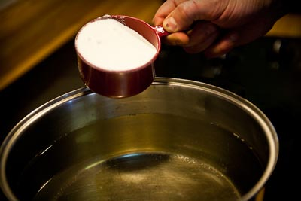
Boiled sugar is coloured using acid free powdered food colours, which have been dissolved in a small amount of cold water.
Pastes and liquid colours may be used, however these tend to contain acid for preservation purposes, which have a soften effect on the finished sugar pieces.
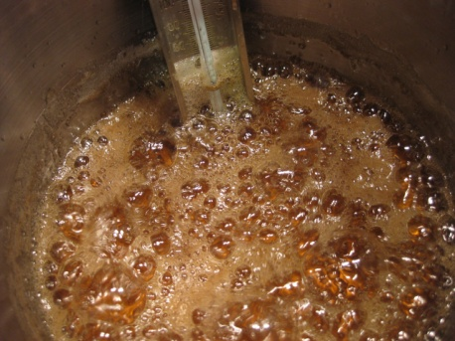
The powder colours, once mixed with water can be stored in a dropper bottle for later use and added to the boiling sugar syrup at 135°C – 145°C, adding the colours at this temperature allows the excess water to evaporate and natural motion of the boiling sugar to disperse the colour throughout the whole pot.
Alternatively alcohol based colours can be used, although more expensive they are very versatile as a number of colours can be made from the one pot of sugar.
The colour is added after the boiling process as the alcohol evaporates, small pools of sugar can be poured from the one pot and individually coloured.
Because of the food laws in different countries colour tones and composition or colour strength may vary.
For example, some colours change during the boiling process, so they should be added near the completion of boiling.
Also, dissolving powder colour in alcohol, as recommended in some old recipes, may result in a completely different shade of colour as it does not dissolve as well.

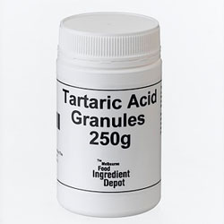
Acid
Tartaric Acid is used in sugar recipes for pulled and blown sugar pieces. It is fast working and heat stable to temperatures of 170°C.
It can be purchased from chemists and most supermarkets.
We prepare Tartaric Acid for use in sugar works by dissolving equal parts of acid and water together; 50 grams of fine crystallized tartaric acid is stirred into 50 grams of boiling water. (A ratio of 1:1).
The crystals should be completely dissolved.
Pour the solution into a pipette bottle so that the acid can be added drop by drop to the boiling sugar:
- Sugar (Sucrose) is a disaccharide meaning that it is made up of two single units. When the sugar is heated and mixed with water and acid, about 2 – 4 % of the sugar can be spilt or broken down into two different single sugars (monosaccharide’s). This causes the solubility of the sugar syrup to rise and helps prevent crystallization.
This also has a softening effect on the sugar giving it some elasticity, enabling us to pull and blow the sugar into desired shapes.
However too much acid results in soft unstable sugar, which may collapse or have a drooping effect on finished pieces.
The sugar will also become very hygroscopic, losing its shine and becoming sticky as it attracts moisture from the air.

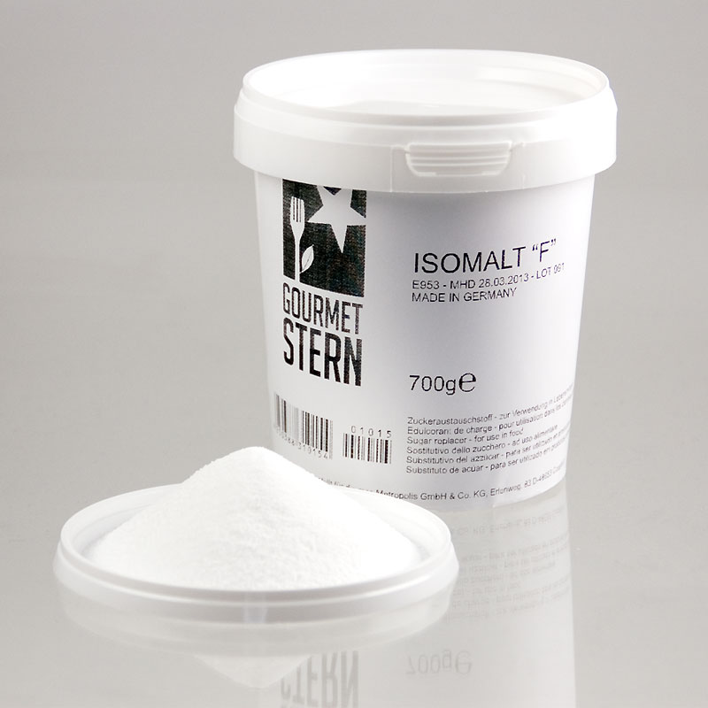
Isomalt
Isomalt is a sugar substitute, discovered in the 1960’s. It is made from sucrose and is white, crystalline and odourless and is a mixture of two disaccharide alcohols, gluco-manitol and gluco-sorbitol.
Isomalt is an alcohol sugar and is made from sugar (sucrose) in two steps.
Firstly sucrose is exposed to an enzyme, causing a reaction which creates isomaltulose, this is then purified via crystallization and then made into syrup.
The isomaltulose is then hydrogenated, by exposing it to hydrogen atoms under pressure and temperature in the presence of a nickel catalyst.
Adding extra hydrogen to the isomaltulose atoms is important as it gives the isomalt extra chemical stability and heat stability:
- Isomalt is a unique, excellent tasting sugar-free bulk sweetener.
It has been used in Europe since the early 1980’s and is currently used in over 70 countries worldwide in a wide variety of products.
Isomalt is ideal for consumers who want to make healthier choices as it has a lower calorie value than sugar and gives a very low blood glucose and insulin response.
Isomalt does not promote dental decay and also supports gut health, however it may have a laxative effect on some people as it acts the same way as strong roughage (Fibre).
Isomalt can be heated without losing its sweetness or being broken down, therefore is ideal for boiled or baked goods.
It can be substituted for sugar in a recipe, giving the same appearance and texture as those products made with sugar and can be found in products such as, hard candies, toffees, chewing gum, chocolates, nutritional supplements, cough drops and throat lozenges.
Isomalt’s sweetening power depends on its concentration, temperature and the form of the product in which it is used.
When used alone, it contributes 45% to 65% of the sweetness that would result from the same amount of sucrose (sugar):
- It enhances flavour transfer in foods, as it dissolves slowly in the mouth giving a longer lasting taste
- Isomalt absorbs very little water, therefore products made with it, such as candies, tend not to become sticky.
This gives them a longer shelf life and they can be packaged together without the need for them to be individually wrapped.

Sugar
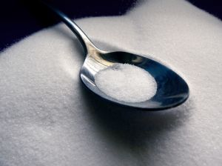
Sugar (Sucrose) is made from the juice of the sugar cane plant, which is made and stored in its long stalks. Sugar mills use large rollers to crush and extracted the juice from the sugar cane.
It is then cleaned to remove impurities and boiled into thick syrup.
Raw sugar crystals are used in a seeding process to form and grow sugar crystals; it is then dried and stored to be sent to the sugar refineries.
At the sugar refineries the raw sugar is processed again, removing any remaining impurities and is graded into sizes ready for delivery to customers.
Sugar comes in many different types and forms, from larger crystal sizes such as A1 through to fine icing sugars and syrups.
For a high quality finished product, it is important that we use a good quality sugar with the least amount of impurities.
Sugar that froths up in the pan contains too many impurities. These may affect the quality of your sugar work and encourage crystallization. It is crucial that the sugar be clean and advisable to use the largest grades of crystal sugar available, as they contain lower amounts of impurities.
If you only have access to beet sugar use a double refined sugar, however you should try to use cane sugar if possible.
Sugar is easily soluble in water which, when cold, can dissolve double its own weight of sugar.
Solubility increases with rising temperatures and saturated solutions would contain.
Temperature °C/F | 12°C/50F | 20°C/68F | 30°C/86F | 50°C/122F | 60°C/140F | 100°C/212F
Sugar per litre of water | 1900gm | 2040gm | 2190gm | 2600gm | 2870gm | 4870gm
Sugar % | 66.5% | 69.5% | 71% | 73% | 75% | 83%

Scales of measurement
In sugar work there are a lot of different measurement systems and scales that can be used to achieve an accurate and consistent product.
There is a direct relationship between the temperature of a sugar solution and it’s viscosity, a few minutes or degrees either way can dramatically change the finished product.
Different types and qualities of thermometers can give a slightly different reading, as well as differing ingredient qualities and environmental conditions. You may find that slight recipe and temperature adjustments may be required.
Below is a chart, which references four different measuring systems, the Brix and Baume scales show readings from hot syrups.

Sugar density and names
Name | Celsius °C |  | Fahrenheit F | Refractometer Brix |  | Baume Be
Thread | 104° |  | 220 | 66° |  | 31
Large Thread | 105° |  | 221 | 70° |  | 32
Blow/Soufflé | 110° |  | 230 | 78° |  | 36
Soft Ball | 115° |  | 241 | 85° |  | 38
Hard Ball | 130° |  | 266 | 93° |  | 42
Medium Crack |  | 145° |  |  | 293
Hard Crack |  | 155° |  |  | 311
Clear Gloss |  | 160° |  |  | 320
Golden Caramel |  | 165° |  |  | 329
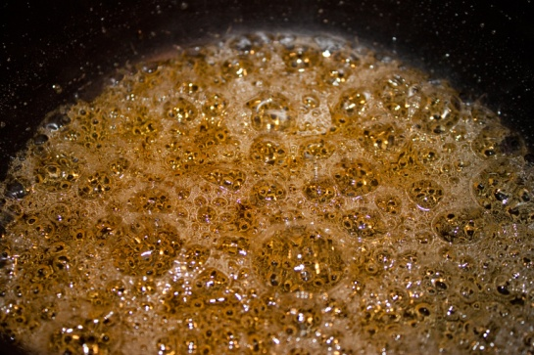
After hard ball stage it is advisable to use a good quality thermometer or physical testing and observation for measuring the consistency of the sugar syrup.
Anders Celsius, a Swedish scientist created the Celsius scale (Centigrade scale).
It is a very accurate and simple system, and is used in many different countries. It is very common to see both the Celsius and Fahrenheit scale list on sugar thermometers and in recipe books.
The Fahrenheit scale forms the basis for the imperial temperature scale, which was used in Australia until it was replaced by the Celsius scale.
The Imperial system was the English system of weights and measures
Fahrenheit was named after the Prussian physicist Gabriel-Daniel Fahrenheit and is still used in many countries, in America it remains the official and most commonly used temperature scale.
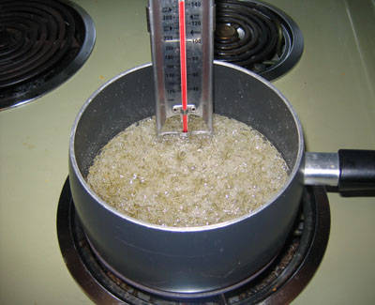
The Brix scale measures the percentage of soluble solids (dissolved sugar in a liquid).
This measuring instrument is called a refractometer and was invented by the German scientist Adolf Brix.
Most refractometers were designed to test syrups at 20°C, however you are now able to purchase refractometers that are designed to test hot syrups.
The sugar syrup is spread onto a glass sample plate and a cover is firmly closed over the syrup, the viewer then looks through an eyepiece.
Light passes through the syrup and is reflected through a prism, the density of the syrup affects the angle of the refracted light.
The higher the percentage of dissolved sugar the more acute the angle of refracted light.
The Saccharometer (sugar measure) was perfected by Antoine Baume, a French chemist, and is used to measure the density of sugar syrup; the laboratory name is a hydrometer (water measure).
It is a very fragile instrument, which measures between 0° and 50°B. When placed into water the Saccharometer will sink to the bottom, as the sugar density of the syrup is increased, it affects the depth of which the Saccharometer will sink.
The denser the sugar syrup the less it will sink and the higher the Baume reading.

1.2 Combine ingredients and prepare sugar for boiling

Water and Sugar

Place the water into the pot and then pour the sugar into the water.
Pouring the sugar into the water helps to alleviate any dry patches of sugar that may burn when heat is applied.
Place pot onto heat and heat slowly to dissolve the sugar:
Use pastry brush and cold water to wash any sugar crystals from the side of the pot:
- Heating slowly prevents sugar burning on the sides of the pot that would discolour the clear syrup.
When the mixture has come to the boil the scum that rises from the solution needs to be skimmed from the surface:
- This is naturally occurring vegetable matter that is found in sugar.
When the syrup has been skimmed then the glucose can be added.
The glucose is used when a softer more pliable sugar is required. Mainly in pulled sugars that are going to be used for modelling. Poured sugar does not need this pliability.

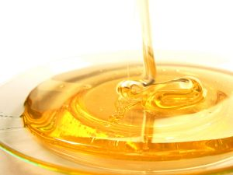
Isomalt
While sugar requires almost half its weight in sugar to dissolve isomalt needs very little.
For every kilo of sugar most recipes will use 45% sugar and then glucose 10-20%.
For 1 kilo of Isomalt 10% water is used.
Place water into pot and add enough isomalt to form wet sand like consistency. Place onto heat and stir to dissolve the isomalt.
When this lot of Isomalt has dissolved add some more. The solution will go milky but keep stirring slowly with heat resistant stirrer.
Do not use wooden spoon unless it is brand new. Wood absorbs flavours and oils and this can contaminate the solution.
Continue to add Isomalt until all dissolved.
Do not wash the Isomalt down from the sides of the pot with water and pastry brush. Wipe with heat resistant stirrer:
- Isomalt needs to be heated to 170°C
- Isomalt will take longer to cool.
Isomalt is more expensive than sugar and the cost has to be justified when deciding which medium to use.

Sugar versus Isomalt
 | Sugar | Isomalt
Cost | Less costly | More costly
Hydroscopic | Highly hydroscopic: the surface becomes sticky when exposed to humid conditions. | Low hydroscopic: the surface is less sticky in humid conditions, which makes it easier to mould with. Mold yeast and fungal resistant.
Shine | Sugar cools faster than Isomalt.  It is easier to achieve a shine when pulling.  The sugar can be worked at warmer temperature yet retain a shine. | Retains heat longer than sugar. Isomalt must be worked at a cooler temperature to attain the same shine as sugar.  This leaves less time to form the Isomalt into the desired shape.  Loses shine immediately in humid conditions.
Colour | Always has an ivory or yellowish appearance from the caramelisation that occurs during the long cooking process. | Does not caramelise. It stays clear.
Crystallisation | Sugar is easier to overwork when it is reused, which causes crystallisation.  Sugar that is rewarmed too often, or at too high a temperature, will crystallise. | Does not crystallise as easily as sugar.  It can be rewarmed and reused over a longer period of time.
Recipes | A large amount of water is required to dissolve sugar when boiling.  Acid and glucose are required for pulling and blowing recipes. | Water is not required to dissolve Isomalt.
Impurities | Contains impurities that must be removed during the boiling process. | Does not contain impurities.
Ewald Notter; 2012; The Art of the confectioner; pastillage and sugar work; p19

1.3 Collect equipment required to prepare sugar

Equipment

Scales
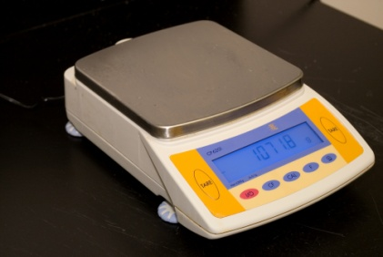
Scales are required to achieve accuracy in weight of ingredients:
- Balance scales
- Digital scales
- Dial face scales.
Types of scales used will vary. Accuracy is all that is required.

Pans
A good quality traditional copper pot with a pouring spout is a great starting point for sugar work.
A freshly cleaned shinny copper pot is an excellent conductor of heat and works extremely well with gas.
However stainless steel pot can also be effectively used for sugar syrups, ensure that they are free from impurities and you have a hot even heat source.
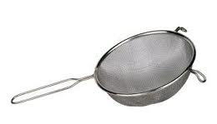
To clean impurities from the surface of the metal is to scour with coarse salt and vinegar then rinse with cold water.

Sieve
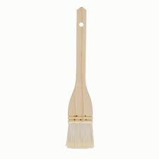
A small sieve or tea strainer is used to remove any vegetable residue or impurities that float to the surface of the sugar while boiling.

Brush
Ensure that you have a clean wide, flat brush to wash down the sides of your pan, with real bristles not plastic, as they will melt.
A dirty or rusty pastry brush can be the main cause of crystallization.

Thermometer
We recommend a mercury sugar thermometer or digital thermometer capable of 180°C.
Alcohol thermometers vary in temperature especially at high degrees.

Gloves
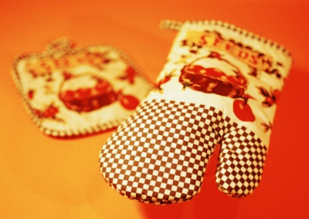
Gloves or oven mitts are required to be on hand because of the heat in the boiled sugar.
As students come to be more experienced they will learn to tolerate the heat better.
The nerve ends in fingers will get used to the temperature and the skin will toughen.
Gloves should always be on hand to lift the hot metal pots and any other metal used in the process.

Marble slabs
Marble has traditionally been used for its properties of handling the heat. When sugar is poured onto stainless steel benches that have been oiled the heat could cause the bench to buckle.
The metal buckles because it expands where the heat is applied and the only way for it to go is up as it cannot expand sideways. This lump will now always be in the metal and ruins the bench for flat pastry work in future.
Marble slabs are best because the density holds the cool and causes the sugar to cool more evenly.
When marble slabs are used for period of time then it will take the sugar longer to cool.
Marble slabs do need to be lightly oiled to prevent the sugar from sticking to the surface

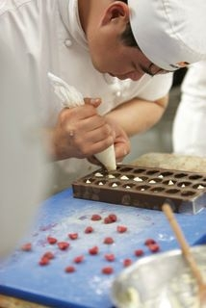
Silicon mats
Silicon mats are now much less expensive than they first came onto the market. Some silicon mats have fibreglass matting through them and this is to increase the strength of the mats.
Silicon is unique in that very little adheres or sticks to its surface and it does not support microbial growth.
They are easy to wash and are reusable. Care needs to be taken not to cut them with sharp objects.
Silicon gloves are now available that can be used in deep frying situations and handling trays directly from the baking ovens.

Work Projects
It is a requirement of this Unit you complete Work Projects as advised by your Trainer.
You must submit documentation, suitable evidence or other relevant proof of completion of the project to the date agreed with your Trainer.
Students will have to plan what they are going to produce.
Students will need to produce a model consisting of the following elements:
- Poured sugar cast piece:
- Three separate pieces that will be part of the final model
- Pulled and moulded sugar piece:
- Flowers, leaves and fruit models
- Moulded and blown elements.
To complete the model is all about planning. The students will need a work plan made of steps that will be required to produce the model.
For this section the student needs to list all the equipment that will be required to cook the sugar solution to the required stage.
1.1 List all the equipment required to cook the sugar solution.
1.2. List the ingredients required to produce all the solution for the finished model.
1.3. Weigh the ingredients required.

Summary

Prepare sugar for boiling
Select and weigh ingredients
Weigh all ingredients to achieve consistency of production and formula balance.
Combine ingredients and prepare sugar for boiling
Mixing the water into the sugar ensures even dissolving of the sugar when the heat is applied
If the sugar is dry there is the possibility that it could caramelise and taint the clear syrup. This is more likely to happen when large amounts are prepared.
Collect equipment required to prepare sugar
Collect all equipment and ingredients prior to beginning the process
When starting the process without all required equipment ensures that will happen.

Element 2:
Boil sugar

2.1 Collect equipment required to boil sugar

Gas, Electric or Induction Heaters
Gas and induction heaters are recommended, as they quickly produce a hot even temperature, which is easy to regulate.

Pans
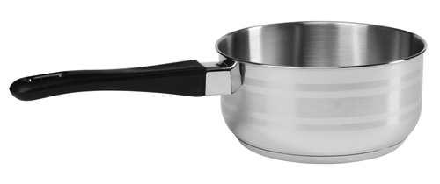
A good quality traditional copper pot with a pouring spout is a great starting point for sugar work.
A freshly cleaned shinny copper pot is an excellent conductor of heat and works extremely well with gas.
However stainless steel pot can also be effectively used for sugar syrups, ensure that they are free from impurities and you have a hot even heat source.

Sieve

A small sieve or tea strainer is used to remove any vegetable residue or impurities that float to the surface of the sugar while boiling.

Brush
Ensure that you have a clean wide, flat brush to wash down the sides of your pan, with real bristles not plastic, as they will melt.
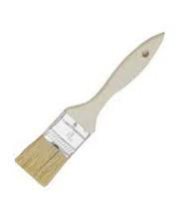
A dirty or rusty pastry brush can be the main cause of crystallization.

Thermometer
We recommend a mercury sugar thermometer or digital thermometer. Alcohol thermometers vary in temperature especially at high degrees.

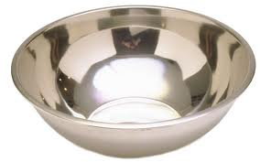
Stainless steel bowls
Stainless steel bowls are used to store products after being weighed.
Bowls are also used for the cold water used for washing down the sides of pots and for cooling sugar that has slashed onto skin.

2.2 Follow specified method of sugar boiling

The sugar boiling process
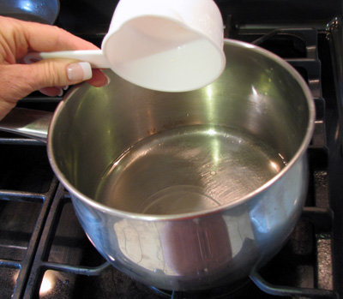
Firstly check the quality of your ingredients, to ensure that they do not contain any impurities.
Flour or other dry ingredients can often find their way into the sugar bin, it is important to always use the purest and best quality of ingredients that you can find.
So if in doubt, open a new bag of sugar or bucket of glucose.
It is important to weight everything correctly, as this can make a big difference to your boiled sugar.

Setting up the work station
Set up your sugar working station before you start and prepare all of your equipment.
This will allow you to be ready for your sugar when it reaches the appropriate temperatures and you will have everything at hand when needed:
- Always work with safety in mind, not just yours but everyone’s.
Being organized and prepared will help you work in a safe and orderly fashion. Hot sugar can be extremely dangerous if it is not handled correctly.
You should always have a bowl of cold water with a few ice cubes in it close at hand, access to cold running water and a properly stocked first aid kit.
Copper pots conduct heat evenly and extremely well.
A traditional copper pot has a copper handle, these get dangerously hot and you will need plenty of thick dry cloths available or a clean oven mite to pick up and handle these pots safely.
The pot should be just large enough to hold the required quantity, to small and your syrup may boil over.

To large and your syrup will sit too low in a deep wide pot, taking excess time to wash down the sides of the pot, you may add to much water, diluting your syrup:
- Before you start your copper pot should be very clean and shinny.
To clean your copper pot you need a tablespoon of salt and the juice of half a lemon, rub to remove any oxidization or impurities on the inside surface of your pot, then thoroughly rinse and dry.
A good quality Stainless Steel pot is an excellent alternative to copper.

Crystallisation of sugar
A major cause of crystallization is slow boiling of the sugar syrup or an uneven heat source.
It is important to cook the syrup rapidly, to ensure a quick turnover of the syrup that is exposed to the surface air.
If this happens to slowly the surface syrup will dry slightly, encouraging the growth of sugar crystals, causing crystallization.
Where icing sugar in the form of royal icing is stirred through sugar syrup, producing rapid crystallization. The sugar syrup, is transformed into a solid state, as it changes from a liquid into a solid crystalline mass.

Place sugar and water into your clean pot

Creating a sandy consistence with the sugar and water will ensure that no dry sugar is left on the bottom to catch and caramelize in the corners of the pot.
Dissolve the sugar and water together by stirring the mixture until it reaches the point of simmering, this will ensure that no large clumps have formed on the bottom which will not dissolve properly, causing the sugar to caramelise or create crystallization.

Do not stir the sugar after it has boiled
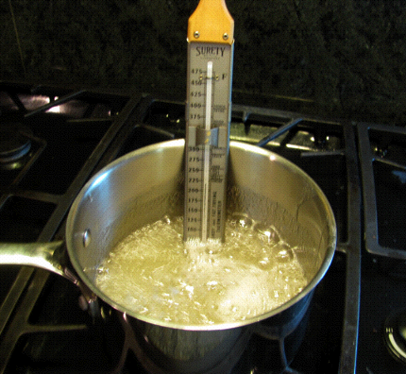
Once the sugar has dissolve and is simmering remove any scum, which has formed on top of the syrup by skimming it off with a fine sieve or tea strainer:
- This can be caused by, left over vegetable residue from the refining process or impurities that have found their way into the syrup.
Brushing down the sides of the pot with a clean brush and water is very important, particularly in the early stages of the boiling process:
- As it removes sugar crystals that form on the sides of the pot, if they are not washed away they will continue to grow and cause crystallization or caramelize and burn.
After the syrup reaches 145°C it is advisable to check your syrup, however there should be little need for brushing down the sides or removing scum.
Excessive washing down of the pot with too much water will dilute the sugar syrup, extending the boiling time, increasing the risk of browning or crystallization:
- Do not stir the syrup after it has reached boiling point, as this will encourage crystallization.

Adding Glucose to syrup
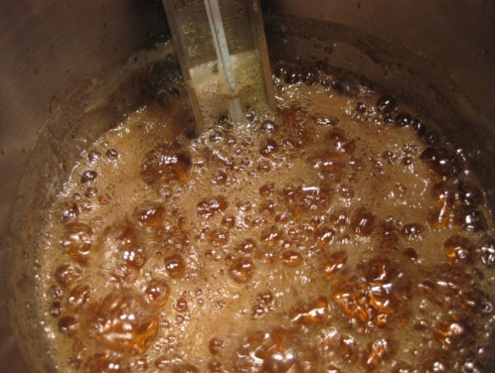
Continue to cook the syrup until it reaches 110°C then add your glucose syrup, adding glucose at this stage allows enough time for the sugar to completely dissolve, then bring it quickly back to the boil and skim again if necessary:
- Remember to wash down the sides of your pot.
Glucose is not added in the first stages, as it holds onto impurities and can also sticks to the pot, making it harder to clean down, leading to dirtier syrup increasing the risk of discolouration and crystallization.
Adding the glucose before the first boil, can cause the syrup to foam a lot more and may lead to over boiling the pot.

Adding tartaric acid to solution
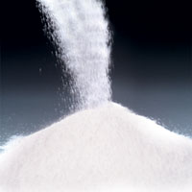
- Tartaric Acid is added to the boiling sugar syrup at 130°C for pulled sugar. It is not required for poured or casting sugar
- The acid will invert a small amount of sucrose (a disaccharide) into two monosaccharide’s, dextrose and laevulose, rising solubility and reducing crystallization
- This results in a softening effect of the sugar, making it more pliable and easier to work with, allowing us to blow and pull the sugar into different shapes.
Continue boiling and monitoring your sugar. If you wish to colour your sugar and are using water based powdered colours add them to the syrup at 135°C – 145°C:
- This temperature may change depending on the final boiling point, amount and type of colour.
The natural boiling motion of the sugar syrup will disperse the colour throughout the whole pot and evaporate the excess water.
Continue boiling your sugar until it reaches 156°C to 160°C.
The higher the temperature the firmer and harder the sugar is to work in your hands.

Stopping the cooking of the sugar solution
When the correct temperature is reached, shock the pan to stop the cooking process by dipping the bottom of the pot into a bowl of cold water.
This is also known as arresting the cooking process, as it stops the sugar from continuing to increase in temperature.
Be sure to wipe the bottom of the pan to remove any excess water as this can drip onto your work surface or your sugar as you are pouring.

Stainless steel versus copper
One of the problems with stainless steel pots is that many will have an aluminium base that is attached to the bottom of the stainless steel pot.
This is because stainless steel is not a very good conductor of heat. Aluminium is an excellent heat conducting metal so pads are attached to the bottom of stainless shells.
Copper is the best but is very expensive.

2.3 Use colours appropriately

Colouring the Sugar
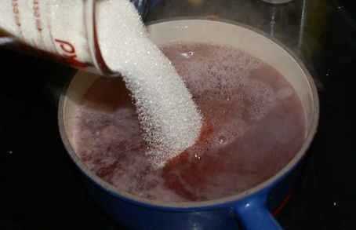
We recommend the following method for the addition of colour.
Dissolve a single powdered food colour in a little water.
Add a few drops of this to the boiling sugar so that the water used to dissolve the colour can evaporate:
- If the resulting colour is too strong it can be lightened by mixing with clear pulled (white) sugar
- Liquid colour is not recommended as it contains an acid as a preservative and this is then an uncontrolled variable.
Because of the food laws in different countries colour tones and composition can vary.
For example: some colours change during boiling process so should be added near the completion of boiling.
Boiled sugar is coloured using acid free powdered food colours, which have been dissolved in a small amount of cold water.
Pastes and liquid colours may be used, however these tend to contain acid for preservation purposes, which have a soften effect on the finished sugar pieces.
The powder colours, once mixed with water can be stored in a dropper bottle for later use and added to the boiling sugar syrup at 135°C – 145°C:
- Adding the colours at this temperature allows the excess water to evaporate and natural motion of the boiling sugar to disperse the colour throughout the whole pot.
Alternatively alcohol based colours can be used, although more expensive they are very versatile as a number of colours can be made from the one pot of sugar.
The colour is added after the boiling process as the alcohol evaporates, small pools of sugar can be poured from the one pot and individually coloured.
For example: some colours change during the boiling process, so they should be added near the completion of boiling.
Also, dissolving powder colour in alcohol, as recommended in some old recipes, may result in a completely different shade of colour as it does not dissolve as well.

2.4 Handle boiled sugar solution safely
Boiled sugar solution is dangerous.

Students need to remember that they are working with temperature that exceed 140°C and the human skins peels off very easily at this temperature.

Safety Safety Safety
When working with boiling sugar solution it is advisable to have bowls of cold water nearby. This is for people to plunge their hands into when they touch the sugar.
The sugar will set and then peel away from the skin after it has cooled.
It still hurts from the pain of the burn but the skin is still attached and will blister and the body will heal.
When there is no water then the pain is more intense and the natural reaction is to:
- Wipe the molten sugar away with the other hand
- Put finger or part of hand into mouth to lick sugar off? Why I am not sure?
Both these natural reaction will cause more harm than good.
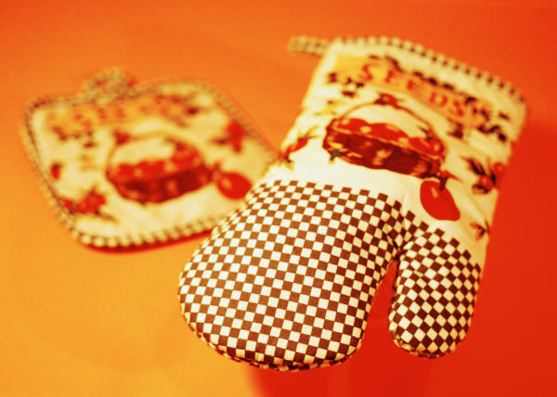
It will cause a second burn to the body.
It is worse when molten sugar gets onto a fingernail:
- A fine needle has to be pushed under the nail to ease the swelling of the blister.
People will learn to keep water next to themselves.
For handling all equipment the students must use PPE (Personal Protective Equipment):
- Thick oven mitts for handling saucepan or pot handles
- Silicon, metal or rubber mats to rest hotpots on the benches.
The pots at this temperature can cause the stainless steel benches to buckle.

Heat resistant materials
Many new products are now available with the development of silicon cooking equipment.
Working with sugar requires absolute cleanliness. Any small speck of dirt can ruin any work when it is embedded in molten sugar.
Cotton is a very good insulator of heat when used in many layers. Silicon impregnated cotton gloves are available and thick silicon gloves can be used in deep frying oil to remove food.
Human hands sweat when exposed to heat for extended periods of time so these items should not be worn for extended periods. Human skin needs to breath.
With time people get used to the heat but care must always be taken. Build up your tolerance over time.
All these products are just a convenience, nothing replaces your skin.
Work Projects
It is a requirement of this Unit you complete Work Projects as advised by your Trainer.
You must submit documentation, suitable evidence or other relevant proof of completion of the project to the date agreed with your Trainer.
Students will have to plan what they are going to produce.
Students will need to produce a model consisting of the following elements:
- Poured sugar cast piece:
- Three separate pieces that will be part of the final model
- Pulled and moulded sugar piece:
- Flowers, leaves and fruit models
- Moulded and blown elements.
To complete the model is all about planning. The students will need a workplan made of steps that will be required to produce the model.
For this section the student needs to list all the equipment that will be required to cook the sugar solution to the required stage.
2.1 Boil the sugar:
- Take care when handling boiling solution.
2.2. Apply colour to sugar.

Summary

Boil sugar
Collect equipment required to boil sugar
It is good practice to develop list of equipment required to accomplish each tasking the kitchen
Student should develop this practice to ensure all equipment is listed
Ensure that the equipment is clean and of durable quality.
Follow specified method of sugar boiling
Read the recipes and follow concise instructions
Add sugar to water to ensure adequate dissolving of the sugar
Stir sugar to ensure dissolving of crystals
When solution boils skim the scum
Do not stir from this point in time
Add liquid glucose if required
Wash down sides of pot to lessen risk of recrystalisation and burning of sugar
Boil to desired temperature.
Use colours appropriately
Add water based colours before boiling process is complete to ensure evaporation of excess liquids
Paste colours can be added to pulled sugars after boiling and before pulling.
Handle boiled sugar solution safely
Temperatures of 150°C plus are in force here so precautions are paramount
Handle all metal objects with care using PPE (Personal Protective Equipment):
Thick cotton gloves
Latex gloves
Cold water
Anything to eliminate the heat and skin.

Element 3:
Pull boiled sugar

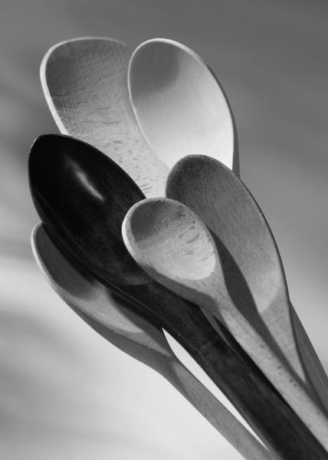
3.1 Collect equipment required to pull boiled sugar
All sugar work products go through the boiling process.
All equipment needs to be clean.
Do not use old wooden spoon for stirring solution as they have been impregnated with oil and other flavours that make contaminate the solution. Better to have a wooden spoon that is ONLY used for sugar work. Better to use metal spoon or silicon stirring equipment.

Marble slab
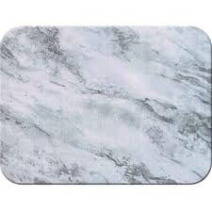
Marble is good to have for its heat tolerance properties. Some specialist marble benches will be cooled. They are placed on refrigerated bench tops that help to keep marble cool that are used over extended periods.
Marble does heat up and will hold the heat the same ways as it holds the cool. Marble is ideal medium in confectioners workspace due to its natural properties.
It will hold room temperature very well and in European climates are popular for their coolness in warm pastry kitchens.
When they are cut flat they are good flat surfaces on which to work.
Stainless steel is easier to maintain but will react to the high heat of the sugar and become distorted and buckle.
High quality stainless steel is less resistant to buckling but this is prohibitively expensive for the kitchen.

Silicon mat
Silicon mats are very useful when working with sugar because the sugar can be easily moved when it is on the mats. Other surfaces can be used. Sugar can be placed on mats then onto trays then in hot ovens without sugar sticking to trays.
Smaller mats can be used to warm sugar in microwaves in small portions.

Pulling hooks
Pulling hooks are required if large amounts of sugar is being pulled. When using small amounts it is as easy to use the bench.
Advantage of using pulling hooks with large amounts of sugar is the weight of the sugar is used to make the sugar stretch before being folded back on itself.
A pulling hook is attached to the wall at a convenient height. 170cm – 180cm.
The blob of cooling sugar is placed on the hook and the weight of the blob will cause the sugar to fall towards the floor.
The person just picks the falling sides up and drops them back over the hook.
This is repeated until the desired satin finish is achieved.
The satin look is acquired because as the sugar is folded back into itself air becomes trapped in the mixture and the bubbles are stretched through the solution and the solution acquires an opaque sheen or satin finish.

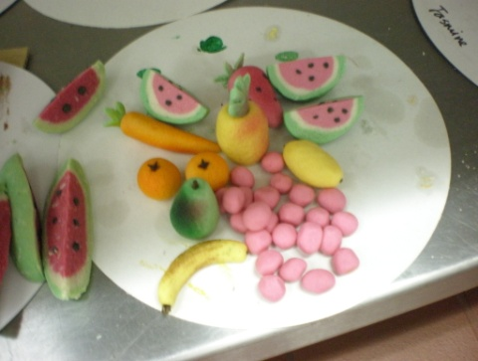
Heat lamps
Heat lamps are used to keep the sugar warm. Variations on these exist but any set up and design can be utilised to keep sugar mass in pliable and workable condition.
After the sugar has been boiled and pulled to required finish it can be cooled and stored until required.
An electric lamp attached to a box is all is required and the sugar needs to sit on a non stick surface. Silicon mats are ideal for this.
In the past special boxes were used with raw silk stretched across the frame or fine wire mesh can be used. Modern silicon mats are now affordable and are the best choice.
As the sugar heats up it needs to be turned to evenly heat through the mass. It is best to use small portions and have them flat; will reheat quicker.
Silicon mat on baking tray inside oven at temperature of 120°C will also achieve same result.

Small equipment
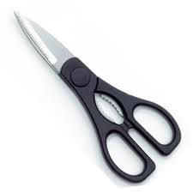
Scissors
- Strong scissors slightly oiled are needed to cut pulled sugars into smaller portions. Smaller portions can be wrapped for storage to be used at a later date
- Pallet knives
- Spatulas.

3.2 Manipulate boiled sugar

Pulled sugar process
Pulling sugar is a process which is used to change the sugar mass from a clear and glassy appearance to an opaque, silky and shiny finish.
During the pulling process air is absorbed into the warm sugar mass:
- The air that is trapped in the sugar reflects the light back outwards
- Causing the sugar to shine.
- Giving our finished show pieces the mother of pearl like sheen.
Pulled sugar is the most versatile and widely used technique in sugar works and is used as a base for many different creative sugar pieces.
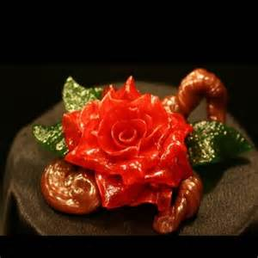
Such as:
- Flowers
- Petals
- Leaves
- Stems
- Grasse
- Ribbons
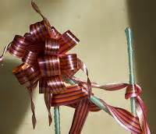
- Bows
- Baskets
- Figurines
- Birds
- Animals.
To name just a few of the many different creative possibilities for pulled sugar work.
Following the Sugar Boiling Process
- Select a pot appropriate to the amount of sugar to be boiled and ensure that you follow all of the basic sugar boiling principles
- Remove any sum that forms on the surface and brush down the sides of the pot with water
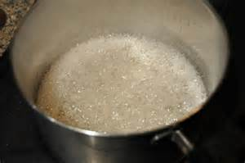
- Using a clean thermometer, boil the syrup to 110°C and add the glucose syrup, which can be warmed for easy addition
- Tartaric Acid is added to the boiling sugar at 130°C
- Continue to boil until 135°C – 145°C. If you are adding water based liquid colours or reconstituted powdered colours, add them at this temperature
- Continue boiling the sugar until it reaches 156°C –160°C.
The higher the temperature, the firmer and harder the sugar is to mould and work with in your hands.
When the correct temperature is reached shock the pot in a bowl of cold water to quickly stop the cooking process:
- Wipe the bottom of the pot on a clean tea towel to remove any excess water as this can drip onto your work surface or your sugar as you are pouring.
The sugar is then poured onto the prepared work surface.
Traditionally this would have been a metal water-jacketed cooling table, granite or marble bench top or slab of marble, which was lightly oiled or coated in talcum powder:
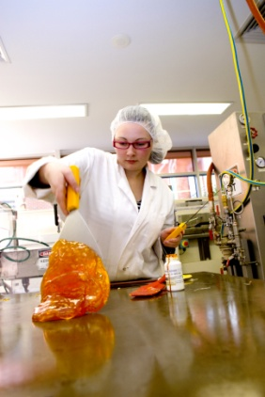
- It is more convenient and hygienic to use a large clean dry silicone mat place on a thick slab of marble
- Allow the sugar to cool for a few minutes or until you notice the edges beginning to cool and thicken.
Using a firm silicone spatula or wearing powder free gloves, pull the outer cooled edges of the sugar back into the middle of the hot sugar mass.
It is important not to let the sugar cool too much around the edges as we need to cool the sugar evenly and quickly to achieve a smooth sugar mass.
Continue to fold the cooler outer edges of the sugar in towards the warmer centre of the sugar mass to maintain an even temperature:
- The quicker the sugar mass is cooled the more sheen you are able to achieve.
Any sugar that sticks to your gloves or spatula and breaks away from the warm sugar mass should be removed and thrown away.
Do not incorporate this back into the warm sugar mass as this may cause crystallization.
As the sugar mass cools continue to fold the cooler edges in to the warmer centre mass, moving it to cooler areas of the marble slab to help the cooling process.
Until the sugar has stopped spreading out and forms a smooth ball.
The sugar is now ready to be pulled, incorporating air to achieve a silky, smooth, shinning mass.

Pulling the sugar
Gently grip the sugar with gloved hands and stretch it out with a twisting motion.
Fold the sugar in half, grabbing both ends again and repeat the stretching and twisting motion, trapping in air as you twist and fold the sugar back in, onto itself.
Repeat this process approximately 15 times until you have a silky, satin sheen.
Over pulling the sugar may cause crystallization or a dulling of the sugar, causing the sugar to lose its satin silky sheen.
You can test the sugar for colour and shin by producing a leaf shape:
- Cut a small portion of sugar away from the sugar mass and fold the sugar in on itself to form a small ball
- Flatten out one side and pinch the edge of the sugar at the centre point with both hands and tear the sugar in opposite directions to form a very thin strip
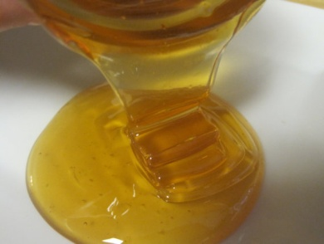
- Form a fine pulled petal shape by grasping the centre of the thin sugar with your thumb and forefinger drawing it out and away from the sugar mass.
When you are happy with the sheen, stretch the sugar mass out and fold the edges in to form a large wide ribbon shape.
Using a large strong pair of oiled scissors quickly cut the sugar into smaller pieces, about the size of a cake of soap.
These conveniently sized portions are easier to evenly re-warm under lamps and store for later use.
Quickly press in the pointy corners of the sugar portions. As these can puncture storage bags or beak off easily, producing fine particles of sugar that will absorb moisture more readily.
Spread the sugar pieces out onto a clean silicone mat so that they are not touching each other, as they will stick together.
Allowing the sugar pieces to cool quickly or place them under sugar lamps for immediate use.
When the sugar has cooled down to about 20°C – 25°C it is ready for storage.

3.3 Store/hold pulled sugar
- Vacuum Packed: This is a very simple and effective method, the sugar portion is placed into a strong plastic bag:
- Using a vacuum sealing machine (Vac Pak Machine), the air is removed from the bag and sealed closed
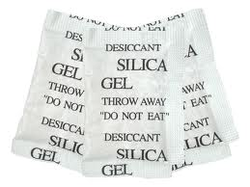
- Preventing any moisture absorption from the air, a drying agent can also be enclosed in the bag with the sugar for effective long-term storage
- Silica Gel: This material is available from most chemist or pharmacy:
- When active it is a bright blue/violet colour, as it absorbs moisture it changes to a pinkish white colour:
- It can be dried out in the oven and used over and over again
- For sugar storage, Silica Gel can be placed with the individually wrapped sugar portions, in an airtight container
- Calcium Chloride: It is slightly caustic, so make sure that it is in a stable container and does not come into contact with the sugar:
- It is a very strong drying agent in the form of small white pearls that absorb moisture and eventually breaks down
- Unslaked Lime (Quick Lime); Available from building suppliers:
- It is best used in hazelnut sized pieces, giving a larger surface area to absorb moisture
- As it absorbs moisture the surface of the lime turns powdery and needs to be replaced.
You can also use dried salt or rice as these both absorb moisture from the atmosphere however the above options are preferable.

Hold modelling sugar warm
To hold the sugar in a pliable or mouldable state it needs to be kept warm.
Heat lamps can be used but if the sugar is under the heat lamps for too long it becomes too soft.
If only a small amount of sugar is required then this can be warmed in an oven on a tray cover with a silicon mat.
Work Projects
It is a requirement of this Unit you complete Work Projects as advised by your Trainer.
You must submit documentation, suitable evidence or other relevant proof of completion of the project to the date agreed with your Trainer.
Students will have to plan what they are going to produce.
Students will need to produce a model consisting of the following elements:
- Poured sugar cast piece:
- Three separate pieces that will be part of the final model
- Pulled and moulded sugar piece:
- Flowers, leaves and fruit models
- Moulded and blown elements.
To complete the model is all about planning. The students will need a workplan made of steps that will be required to produce the model.
For this section the student needs to:
3.1 Boil sugar and pull sugar to required finish:
- What process will you be following to obtain the required product
- Remember to use safety equipment when handling sugar
- Gloves are recommended.
3.2. Store pulled sugar until required:
- State how the sugar will be stored and what will be the requirements for storage to be successful.

Summary

Pull boiled sugar
Collect equipment required to pull boiled sugar
All equipment needs to be in good condition and very clean. Make sure you have all equipment required before beginning then you do not need to halt the process to look for equipment.
Manipulate boiled sugar
Using clean hands and clean lightly oiled equipment, fold the molten sugar back in on itself until the sugar can be handling safely.
Store/hold pulled sugar
When the sugar has cooled and been divided into more convenient portions it can be wrapped in plastic wrap to protect from the air
Sugar is hydroscopic, meaning it attract moisture to its surface and the moisture causes the sugar to dissolve. When the sugar dissolves the sugar structure collapses
Keep it wrapped and dry.

Element 4:
Use pulled sugar to produce display sugar work

4.1 Collect equipment required to produce display sugar pieces

Types of equipment

Gas torch or alcohol flame
A heat source is required to melt sugar so a bond between two pieces of sugar can be achieved.

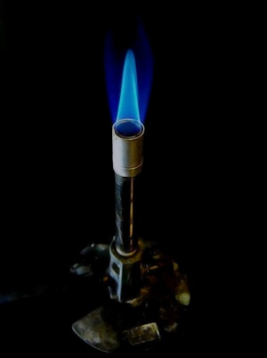
Silicon mats
Silicon does not bond to the molten sugar. Always have one on hand.

Stands
The sugar piece will need to be placed onto a stand for display purposes.
It can be a plate of over several tiers if you so desire.
A stand or platter to place the sugar display on is paramount importance.
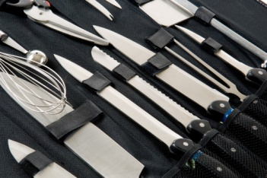
Sugar is fragile and breaks at the slightest bump, so to be able to move it around a display tray, stand or platter is required.

Knife
A good quality knife that can be used to cut sugar as required.

Air pump
To blow shapes a hand pump with a non returnable valve attached to a length of thin copper tubing is ideal for this. Some practitioners will blow with their mouth. http://www.pastrywiz.com/sugarart/sugarswan1.htm

4.2 Produce blown sugar shapes
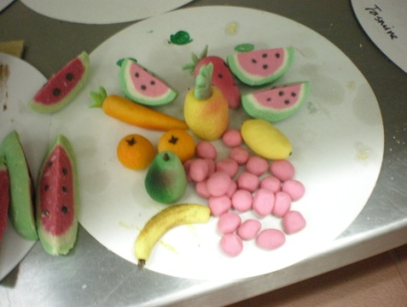
Blown sugar shapes may include:
- Fruits
- Animals
- Figures:
- Clowns
- Cars
- Motorcycles.
Blown sugar is three dimensional and it tends to be very delicate.
Poured sugar is much stronger because it is thicker. It can be layer to produce the third dimension.
YouTube Chef Robert Lombardy: Inland Northwest Culinary; Spokane; Washington State; USA.
http://www.youtube.com/watch?v=vxciGVtOmFg

4.3 Produce ribbons and bows
Ribbons and bows are produced by using multiple coloured sugars. Each of the coloured sugars are produced individually.
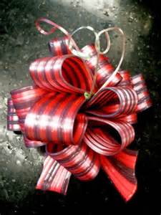
There can be one boiling of sugar then divide onto various positions on marble or silicon mats then individual colours to each lot of sugar.
The colour added paste from and folded in. this action needs to be done quickly and proficiently.
Not recommended for the beginner.
Get three people to make one colour each and share.
Three or two equal portions of coloured sugar are rolled and laid side by side.

Refer to YouTube website:
How to make pulled sugar ribbons by Pastry chef Patrick Fahy of Chicago Hotel Sofitel.
http://www.youtube.com/watch?NR=1&v=v1FRBsm2Gk0&feature=endscreen
- When the sugar has been warmed then lay them side by side and run your fingers down the length of the sugar.
- This will stretch the sugar, do not pull on the sugar because there will be uneven pressure and thickness will vary.
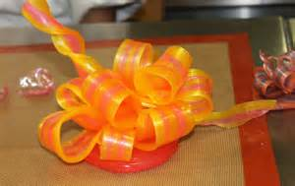
- Fold strip over to make shorter and join two edges evenly together.
- Repeat the sliding motion between fingers.
- Slide fingers the length of the sugar and it will lengthen.
- The sliding must be gentle if you pull hard on the sugar it will break.
- When the sugar is at the thickness you need cut into portions with a hot blade.
- Place under the heat source to soften strips as required and gently mould to shape.
- A fan can be used to cool sugar until it holds its shape.
- When all pieces have been moulded then the ends can be heated with a flame to soften the sugar until it is soft enough to bond to another piece of ribbon.
- Working from the outside into middle.
- Hold in place until cool enough to support its own weight.
- Continue until all assembled.

4.4 Shape sugar pieces into leaves and flowers
Sugar can be moulded into many shapes. Classical shapes are roses and daises because the petals are easy to form.
Sugar is fragile and care needs to be taken when working
Plan to have breakages when assembling so produce more than you need.
When moulding the leaves and petals most will use their hands and skill to get the shape just right will need to be developed:
- This is just practice.
Hand moulded flowers and leaves will normally be made with pulled sugar.
With the increasing use of silicon moulding many larger displays can be made with poured sugar.
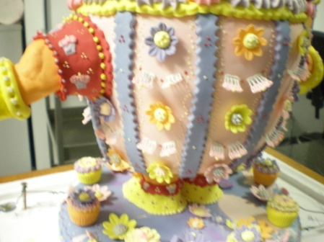
This allows for more clearer displays and thicker mouldings allow for higher more extravagant displays:
- The larger the display the larger the pieces need to be
- The larger the pieces become the larger the workspace needed
- The larger the pieces the more fragile they become
- Keep it in control and keep the grief minimal
- Keep it small and controllable.
Moulds can be purchased to mould leaf shapes; warm the sugar to pliable mass and place between the two pieces and press.
Silicon moulds can be purchased for pouring or pressing sugar.
More expensive moulds can be acquired made out of metal but are expensive as they are moulded out of aluminium.
- Leaves are mostly hand moulded to shape.
It is best to have a flower that you wish to copy next to you when you are moulding or a good quality photograph.
When sugar is warmed and ready pull a piece away from the mass and stretch and shape with fingers until the shape is achieved.
This will need to happen quickly as the sugar cools quickly when it is away from the mass. Isomalt cools quicker.
Do not look for perfection. The more you practice the easier it will become and the shapes will come quicker.
Hand press can be made from silicon if repetition of piece is required

4.5 Weave sugar to form baskets
Basket weaving is an intricate art form of the pulled sugar display.
A wooden stand is required with holes drilled at regular spacing’s.
In these holes will be small pieces of wooden dowelling coming out of the wood.
If a basket wider at the bottom than at the top is required then the dowelling needs to be angled out.

Making a pulled Sugar basket
- Base
- Woven basket
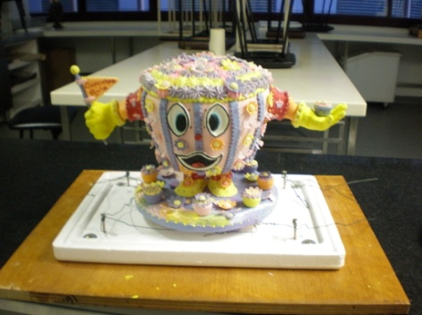
- Plaited edging for bottom and around the top
- Handle
- Wire frame for handle
- Decorations
- Blown fruit to sit inside
- Display base; can be any medium that will carry the moulded sugar.

Base
This needs to be slightly wider than the dowelling frame.

Woven basket
When complete it should sit inside of the flat base; can be round, oval or square.

Plaited edging
A plaited edge for the base and to sit on top of weave. This is to help hold it securely.

Dowelling replacements
Roll out some of the sugar to forms lengths that will replace the dowelling pieces when removed. This can be in long lengths and then use hot knife blade to cut to length.
Remember to cut them so they sit just below the top of the weave. This will be topped with another twist or plait.

Handle for basket
Take a piece of wire and twist it to resemble the size and shape of the handle desired. Ensure it will fit the woven basket because after the sugar handle is made it cannot be adjusted. Any change in shape will crack the sugar handle.

Decorations
These can be myriad of items. Normally some small flowers of contesting colours with some green vines and leaves attached.

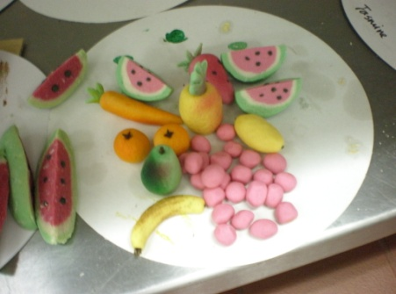
Blown sugar fruits
Traditionally this is what the decorations would have inside to highlight the skill of the craftsman but there is no reason it has to be sugar. It can be marzipan fruits, especially if it is a small basket.

To weave the basket:
You start with a piece of coloured pulled sugar.
The sugar needs to be heated until it can be handled and shaped easily but will hold shape when pulled.
Start by moulding one end of the sugar lump into a strand of the thickness you wish to plait and it is about 5 cm long.
Place this at the back of one of the dowel pieces and weave around the next piece of dowel and then back inside the next.
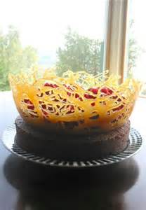
As you are doing this you need to twist the sugar lump in your hand as you pull out the strand. Do this slowly.
As the sugar is used up or cools to a point where it cannot be stretched out and twisted then the sugar needs to be re-warmed.
You will need several pieces of the sugar to make the entire weave.
Remember: Each new piece of sugar needs to start on the inside of the basket so the join cannot be seen from the outside.
When pulling try get the twist and thickness the same all the time.
The twisting evens up any inconsistency in sugar and strengthens the sugar.
Continue until the height required is reached.
Do not make the plait too tight around the dowel pieces. They have to be removed.

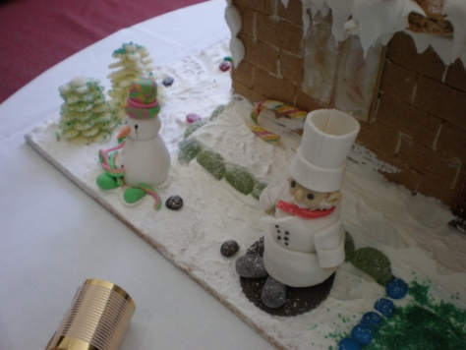
To assemble the basket
Lay the sugar base onto display base.
Remove the dowelling from the woven section and replace with the lengths of sugar.
Join sticks of sugar to weave using molten sugar as glue.
When set lift the woven section onto base and attach with molten sugar.
The sugar for around d the base can be three or two pieces long enough to go round the base of basket. If it is too long it can be cut. If it is too short you need to remedy the problem. Start again.
Next weave 3 pieces flat and lay on top of plait.
When securing all weaves to basket try to make all joins inside and at back of the basket.
Next take some sugar and twist thinly around piece of shaped wire. Use enough sugar to complete in one attempt.

Weaving a sugar basket and fruits
You tube
The art of sugar craft; filmed and edited by Leon Arndt, ICT Services.
http://www.youtube.com/watch?v=7vK7lTghbe0&feature=g-vrec

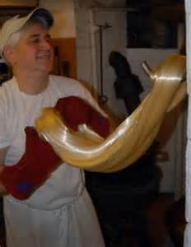
Pulling sugar on a hook
You tube
Handmade candy cane demonstration at Logan’s candies Ontario, California USA.
http://www.youtube.com/watch?v=CPEHsj3UDR4&feature=related

Work Projects
It is a requirement of this Unit you complete Work Projects as advised by your Trainer.
You must submit documentation, suitable evidence or other relevant proof of completion of the project to the date agreed with your Trainer.
Students will have to plan what they are going to produce.
Students will need to produce a model consisting of the following elements:
- Poured sugar cast piece:
- three separate pieces that will be part of the final model
- Pulled and moulded sugar piece:
- flowers, leaves and fruit models
- Moulded and blown elements.
To complete the model is all about planning. The students will need a workplan made of steps that will be required to produce the model.
For this section the student needs to:
4.1 List required equipment.
4.2. Produce 3 blown shapes:
- Round and elongated.
4.3. Produce a ribboned bow with three colours in ribbon.
4.4. Shape and mould 6 leaves of various sizes and one central rose.
4.5 Weave sugar.

Summary

Use pulled sugar to produce display sugar work
Collect equipment required to produce display sugar pieces
Pulling sugar needs to take place immediately after boiling so it will be hot
Safety is paramount and safety PPE is required
Gloves; heat lamp; scissors; knife; model presses
Spirit gel burners.
Produce blown sugar shapes
Warm the end of reed or thin copper pipe used for blowing and attach warmed sugar to form a seal
Gently pump air into sugar and form require shape.
Produce ribbons and bows
Use two to three colours and roll finger lengths pieces. Place together side by side and gradually slide then longer and thinner
Do not pull; this can create uneven.
Shape sugar pieces into leaves and flowers
Prepare sugar with colour and allow to cool until required
Store in small pieces
Warm small piece and shape as desired.
Weave sugar to form baskets
Obtain a base sugar basket mould. Wooden base with sufficient holds to hold small pieces of aluminium strips or tubing
Draw an shape of basket; usually oval. Mark out where holes will be drilled; space approximately 2cm apart. Drill hole at approximately 80° angles to make top wider than the bottom
Place strips of metal into holes and you are now ready to plait sugar
Prepare sugar and start to pull a thin strip and begin weave
Refer youtube for method of weaving basket
The art of sugar craft; filmed and edited by Leon Arndt, ICT Services
http://www.youtube.com/watch?v=7vK7lTghbe0&feature=g-vrec.

Element 5:
Pour boiled sugar to produce cast display sugar work

5.1 Collect equipment required to produce cast display sugar work pieces
Moulding sugar pieces can become an engineering experience that would make any engineer proud. This is the challenge to the Confectioner or Patissier undertaking this challenge.
Equipment need will vary depending on the job and shapes being undertaken.

Moulds

Silicon moulds
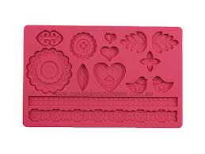
The use of silicon in Sugar Moulding has increased in the last 10 years that now there are many pre made moulds available on the market:
- These are convenient if the same design will be used over and over
- Easy to replace cast parts if they break.
Silicon can be used to make your own design but decision of cost needs to be made.
Food safe silicon is more expensive than normal silicon moulds.

Plasticine
Plasticine is available at any modelling shop and can be rolled flat and cut outs removed and the remaining shape used for the poured sugar.
Stencils are kept of the required shape so any new piece can be reproduced quickly and as needed.

Stencils
Shapes cut outs from durable stiff plastic covers can be easily stored for cutting plastine to shape as required.

Metal strips
Metal strapping can be used but other mediums are more space efficient.
Any moulds that are shaped need to be stored and unless the shape is to be used multiple times then the storage requirement becomes problematic. Where to store the moulds?
Casts for shape like shells and textured surfaces are best made out of silicon if going to be used multiple times.

Metal shapes
Any metal shape can be utilised as a mould for cast sugar.
Metal strapping used to be used along with plasticine to hold in place but the use of this was time consuming and the metal strips needed storage was required for strapping when finished.
Metal pastry cutters make excellent moulds for cast sugar.
The practitioner will build up collection as they develop skills and work experience.
Do not buy the plastic pastry cutters for this unless you know they are heat resistant.

Designing shapes
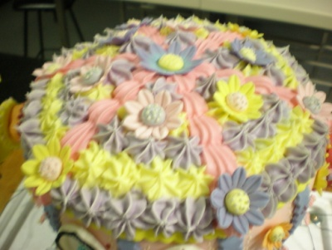
For the simple and quick preparation of a cast sugar show piece we have to plan various forms by using rubber mat and cutter.
You could cut out a rubber mat out of yourself. Ideas for suitable designs can be found in magazines, children books, on festive cards, etc depending upon the subject needed.
Making a form from a detail drawing, pouring basic shapes/sections then adding detail by painting or piping later all needs to be planned.
A very important factor to consider is that the heaviest part is at the base of the show piece, and that it stands securely.
Basically we plan the show piece that the areas in the upper part are poured directly onto each other and next to each other. The pieces in the lower section are attached to each other when cold.
This is made stronger by pouring a mirror image to attach to the other side of the piece and stabilizing factors i.e.: legs added either side to give additional strength and support at the base of the piece.
Alternatively we can strengthen the piece with a support which is not so obvious made of clear sugar and if possible place on the reverse side of the piece.
If a motif has important sections which do not lie directly next to each other, we can fill the areas in between with clear sugar. Using this technique can we also break up optically heavy large, areas of poured sugar.
It is advised to make a drawing of the outside borders of the piece onto a letter sized piece of paper and correct the drawing until you are happy with it. Then enlarge the picture to the required size and cut cardboard stencils out of every section to be poured.
The cardboard stencils are attached individually to the rubber mat with double sided tape and cut around with a strong craft knife.

Small equipment
A tool box of small engineering tools may be needed when working with sugar. It is a requirement that these are not actually used for any other work than food related work.
NEVER work on machinery with these tools.
These may include:
- Pliers
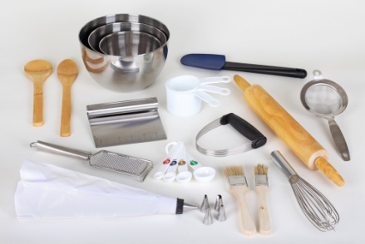
- Scissors
- Pastry brushes
- Fine paint brushes for delicate work
- Pallet knives
- Utility knife
- Paper Piping bags
- Plastic sheeting to cover workbenches.

Aluminium foil
Can be used as a base on which to cast boiled sugar.
Shaped into small balls can be used to support finished pieces if required.

Plastic wrap
Can be used to support finished pieces in small containers, stops them from moving around and getting damaged.

Plastic containers
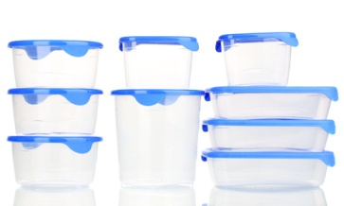
- Round
- Square
- Rectangular
- Any shape or size.
These come in handy to secure finished pieces until required for assembly inside small containers.

Bench tops
Bench tops for sugar work need to be sturdy. Stainless steel tends to buckle due to the rapid changes in the heat. It buckles because it only expands where it get hot and when it cannot move sideways anymore it moves up. It does not contract to correct shape so stays misshapen.
Marble or Granite of 20 to 30mm thickness are good and last a long time if not cracked due to back handling.
Steel benches that thick also work well with the heat but are far too heavy.

5.2 Add specific ingredients to create effects

Special affects
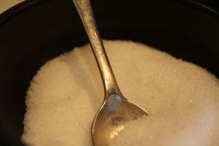
Cast sugar will be clear unlike pulled sugar that becomes opaque (cloudy) with the addition of the air due to the folding and stretching.
Special effects can be achieved with moulding in silicon or even just using wrinkled aluminium foil as a base and a metal cake ring will add eye appeal to cast mould.
If a non clear finish is required or a more dominant colour affect then additions to the boiled sugar can achieve this change.

Calcium carbonate
This is a natural substance used wide in the food industry, also found in toothpaste.
Dissolve equal portions into hot water and keep until required.

Titanium dioxide
Add Titanium Dioxide to the sugar to make it opaque/milky.
For 1 kilo of sugar add 5 drops of Titanium Dioxide to the sugar at (145°C).
Solution preparation: mix 1 Tablespoon (20ml) of Titanium Dioxide with 50ml of water, stir and dissolve. Add the require amount into the boiled sugar.
Gold and silver sparkle can be added for effect when casting single colour sugar. It can be added in the boiling process or added when it has been poured onto the marble slab or silicon mat.

5.3 Pour and set sugar

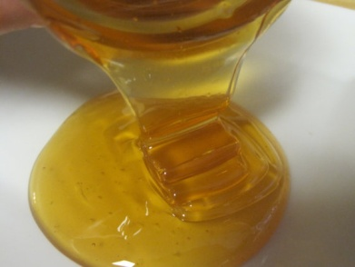
Prepare to pour
The mould shapes need to be set up before you boil the sugar.
The mould must be secured to the surface so it does not move when sugar is poured.
Hold the mould in place by using plasticine on outside at set points to hold in place.
The internal surface that the sugar is going to touch has to be oiled to prevent sticking.
The oil needs to be enough to stop sugar from sticking but if too much is applied it may affect the sugar.

Pouring the sugar

When the sugar has reached the desired temperature the base of the pot must be placed into cold water bath:
- The cold water bath is to arrest the cooking process and stop the sugar from boiling
- Hold the pot in the water until the sugar has stopped boiling
- You do not want any bubbles in the cast sugar.
When all movement has stopped but there may be some small bubbles still visible in solution, give the pot a gentle tap on the bench top to get the bubbles to rise to surface and break.
Warning: DO NOT tap so hard that the sugar splashes out of the pot.

Pour
- Start at one end of the mould and work towards the other end
- Pour in one motion.
If the sugar cools and it needs to be 'topped up' then a wave will appear in the mould:
- Pouring takes practice and several attempts may be needed.

5.4 Release sugar from forms
Allow the sugar to cool in mould and when it has cooled enough to hold the desired shape they mould must be removed:
- Never let sugar cool completely in mould
- If it is set hard then it is not flexible
- If it is not flexible it will crack
- If it cracks, remelt and recast
- Casting sugar is unforgiving.
If the cast model has cooled completely it may need to be rewarmed in the oven to soften the sugar.
Place into an oven at 120°C and leave to warm through and then repeat the cooling process until the cast can hold shape.
When model is removed from mould place onto an acceptable surface and set aside to cool completely.
Sugar cast in Silicon is able to cool longer in mould because the mould is flexible as is easier to get off the cast.
When the moulded sugar is cooled completely it need to be placed into a secure storage environment until required for assemble.
This storage needs to be dry so when packing moulded pieces it is advisable to include several small sachets of silica gel to absorb any moisture in the air.

Cleaning the mould after use
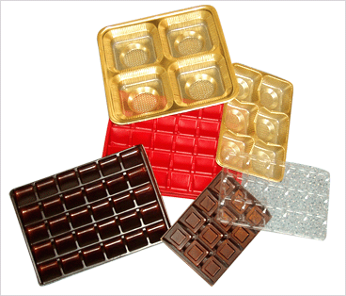
When the sugar has been released from the mould they need to be wiped clean using dry cloths.
Any sugar that has stuck to the moulds needs to be chipped away and the mould cleaned.
If the mould has been oiled correctly then the sugar will not stick.
If the moulds are clean when stored away they will be ready for use the next time.
Easier to clean the moulds while they are still warm.

Work Projects
It is a requirement of this Unit you complete Work Projects as advised by your Trainer.
You must submit documentation, suitable evidence or other relevant proof of completion of the project to the date agreed with your Trainer.
Students will have to plan what they are going to produce.
Students will need to produce a model consisting of the following elements.
- Poured sugar cast piece:
- Three separate pieces that will be part of the final model
- Pulled and moulded sugar piece:
- Flowers, leaves and fruit models
- Moulded and blown elements.
To complete the model is all about planning. The students will need a workplan made of steps that will be required to produce the model.
For this section the student needs to:
5.1 List equipment to cast sugar.
5.2. Cast four separate shapes to be used in model:
- Round Square, Triangular and Geometrical curves
- Add colour or ingredients for special effects.
5.3. Release and store until required for assembly:
- Ensure the piece is protected from hazards.

Summary

Pour boiled sugar to produce cast display sugar work
Collect equipment required to produce cast display sugar work pieces
Make sure you have all the required equipment before you begin the task of casting.
Add specific ingredients to create effects
Organise the special affect before you begin
Special effects can be added to the mould or it may be added into the sugar
This needs to be added before the boiling is completed. This is to allow any excess moisture to be evaporated away before the cooking process is complete.
Pour and set sugar
Pour the sugar solution in one movement
Eliminates waves in cast
All to cool in mould before removing
Must be able to retain shape but must still be pliable.
Release sugar from forms
Release from mould while still warm
If cast has cooled completely then it can be placed back into an oven to warm through to be removed
Do this slowly to heat the internal part of the cast
If the centre is cold then it will crack and spoil the look of the cast
Set aside to cool completely before packing away.

Element 6:
Plan sugar display piece

6.1 Plan display piece appropriate to client, occasion or theme able to be produced in time available using a variety of techniques
Client needs
When designing to client needs it is important to have several styles available to show your particular style.
It is difficult to understand what the client requires if they cannot see your style.
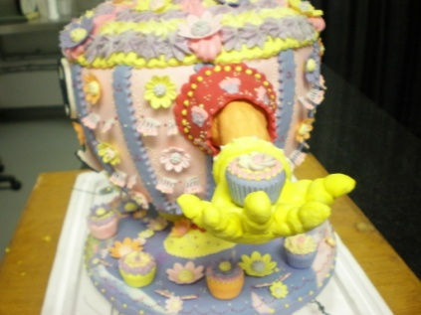
They need to match. Themes may relate to:
- Seasons
- Sport
- Pets
- Celebrations
- Weddings.
When introducing a client to your work it will give them an idea of what can be achieved.
Keep designs based an achievable size:
- 1 meter high
- 750mm width.
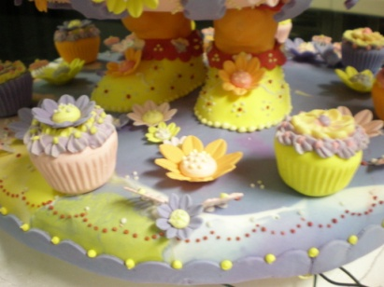
This is BIG!
- 30cm high
- 15cm wide
More achievable.
What is style of design?
Start with geometric:
- Triangles
- Squares with holes cut out of centre
- Circles with triangle cut outs off set from centre.
Design is an adventure. Start simply grow your designs as you grow your skills.
Now! Stick them all together and make a story of what they represent.

6.2 Prepare a sketch or outline of display
The drawing is just to give a guide of what you are trying to replicate.
From the sketch templates can be cut to meet specific size requirements.
There are templates in specialist books available online or the practitioner has to develop drawing skills.
When the model has been drawn the break the finished piece down into elements.
In Roux Brothers Patisserie there is a template example in the back of the book:
- Template page 246
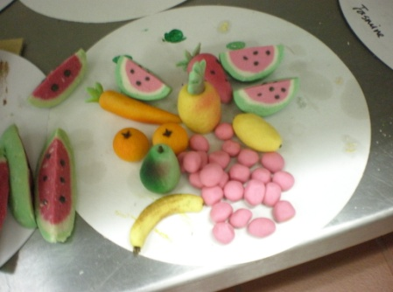
- Assembled model page 230 'Pink Flamingo.
Five main portions to the finished sugar work display.
When developing your plan be sure to note any characteristic that will be applied to each piece.
Make a list of all the tools that you may require, include all consumables as well.
Plastic cups that are used to hold blown balls so they do not rest on flat surface and develop flat sides.
Plastic wrap that can be placed inside plastic container to take weight of sugar ball and not cause any weight to be applied to any one area of the model.
Plastic wrap crinkled or crinkled aluminium foil layer onto flat baking or storage tray is a good way to keep pieces in position.
This minimises possibility of damage caused by pieces moving around or when tray is bumped, sudden movement is minimised.

6.3 Prepare forms and shapes as required by the design

Choice of the casting form

For A One Time Form
Plasticine is rolled out to 3-4mm and then the drawing or stencil laid on top. Paper can be weighted down with metal bars so that it does not slip.
We then cut through the drawing, or along the stencil, or push through the drawing with a pencil.
Once the form is cut out cleanly the inside edges should be oiled and the corners lined with aluminium foil.
The plasticine gets very hot on these extreme points and without the barrier of aluminium foil would stick to the sugar.
Scratching the plasticine away is difficult and does not add to the beauty of the piece.

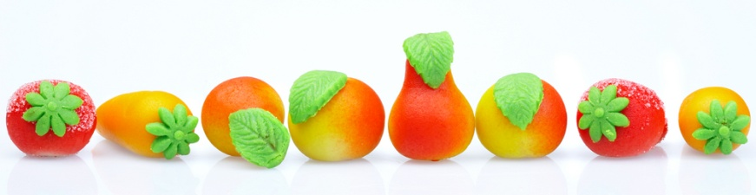
For A Small Show Piece
The oldest method of form preparation can be used here – the cardboard stencil. We cut the desire motif and lay it onto oiled marble.
Then dust 2mm of starch powder over the form and remove the cardboard. Pour sugar into the exposed shape.

For Simple Shapes
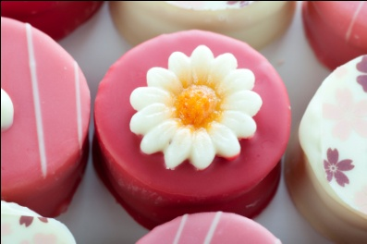
For simple shapes that are often required steel band is very suitable.
We do recommend this material for complicated shapes, since it is not easy to bend the steel and it does not lie flat on the surface.
Steel band, cutters, rings and metal bars as borders should be oiled before pouring sugar into them.
Shapes are easier to produce with silicon noodles. These can be purchased from specialist suppliers of silicon products.

For Elaborate Shapes
Rubber or neoprene is the most suitable material and is reusable. Using rubber mat is the most economical and easy to cut but is not really suitable for food purposes.
Alimental and some other types of rubber which are non-toxic are suitable for food purposes.
We stick the design onto the rubber with double sided sticky tape and mark through with a scalpel. After this we can cut through the rubber with a craft knife.
The inside edges are then oiled to prevent the sugar sticking.

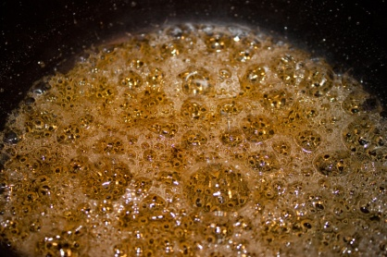
6.4 Calculate quantities required for components of display piece
How long is a piece of string?
Always boil more sugar than what is required.

Preparing sugar solution
Many practitioners will prepare sugar solution to a certain point and then store until required.
Dissolve sugar in water and bring to boil, skim the surface and add the liquid glucose if desired and continue to boil the solution to 106°C then cool and store until required.
This methods allows for solution to be boiled in smaller batches for casting or moulding without going through the start up process every time.
This method is suitable to practitioners who will be doing a lot of sugar work. For those just doing sugar work on occasional basis it is not necessary.
When moulding to cast sugar extra is going to be needed in case of breakages.
When a piece is designed that is going to be used many times then it is convenient to know exactly how much will be required.
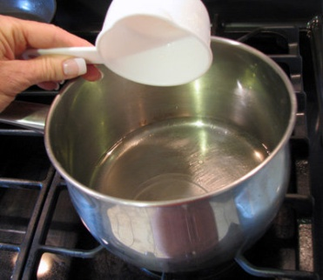
As a rule allow for 30% more than the weight of the final piece, sometimes 50%:
- Sugar is not expensive
- Isomalt is expensive to purchase but the moulded pieces last longer so the expensive is returned by the longevity of the piece.
If multiple colours are going to be required then the amount of sugar for each piece will need to be calculated and records kept so the work can be replicated later.

Work Projects
It is a requirement of this Unit you complete Work Projects as advised by your Trainer.
You must submit documentation, suitable evidence or other relevant proof of completion of the project to the date agreed with your Trainer.
Students will have to plan what they are going to produce.
Students will need to produce a model consisting of the following elements:
- Poured sugar cast piece:
- Three separate pieces that will be part of the final model
- Pulled and moulded sugar piece:
- Flowers, leaves and fruit models
- Moulded and blown elements.
To complete the model is all about planning. The students will need a workplan made of steps that will be required to produce the model.
For this section the student needs to produce their plan for their display using the shapes.
6.1 Design their display piece:
- Start with a rough sketch.
6.2. Provide templates for cut outs:
- If casting in modelling clay or plasticine students will have to have a template from which to cut the mould.
6.3. Prepare a hand moulded pieces as needed from design:
- If moulding one piece in.
6.4. Provide and estimated weight for finished product:
- Remember to allow for breakages
- You will need more sugar solution than you actually use.

Summary

Plan sugar display piece
Plan display piece appropriate to client, occasion or theme able to be produced in time available using a variety of techniques
Have some samples to show the client what you do and what is available
Most clients do not know what is available and what is feasible.
Prepare a sketch or outline of display
Develop a sketch of what you want to display
Divide it into elements
Write instructions for preparing each piece.
Prepare forms and shapes as required by the design
Follow instructions given from the plan
Prepare forms as per design
Forms can be freeform or moulded.
Calculate quantities required for components of display piece
Always allow more than what is going to be required
Cast extras if needed and as precautions for breakages
Allow for up to 50% more than in final product.

Element 7:
Assemble and display sugar work piece

7.1 Assemble sugar work
An idea needs to be formulated and recorded so the final product can be produced.
Draw the design.
Number the pieces and mark where they sit in the design.
Keep notes on how they will be attached to the model.
Show touch points where molten sugar will be placed so pieces can be joined.
PLAN

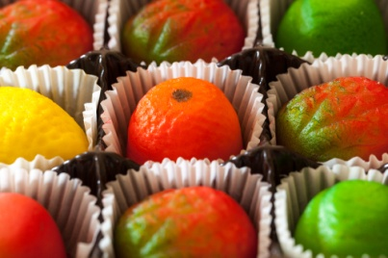
Assemble
Base needs to be positioned on display medium.
Unless the finished pieces can be lifted onto the display stand after it is assembled then you have to work from the display base:
- Position the sugar base onto the display medium
- Follow the plan and attach the main pieces together.
Attaching is using molten sugar and running it onto one piece then attaching it to another while the sugar is soft or using a hot metal object and touching a piece of moulded sugar to soften then touching another piece to bond two pieces together.
Hold pieces together to keep in position until sugar hardens again.
Heating sugar is several ways
Have small blow torch with gas going to use as needed.
Use small tin of methanol gel with a wick to supply flame as heat source:
- Cheaper and more convenient then re-supply of gas containers.
You Tube Video
Assemble moulded sugar art:
http://www.youtube.com/watch?v=xwKxbozpu1s&feature=related

7.2 Decorate sugar work piece
Decorating sugar work should be kept to a minimum as the sugar piece and the display of the craftsman skill should be the decoration on its own.
If highlighting portions of the work needs to take place then seal the sugar with a lacquer spray and then apply highlights with paints, food colours or royal icing after the lacquer has dried.
Other coloured pieces may be applied after main body has been assembled but too much of this can be detrimental to eye appeal. Less is more.
Modern display pieces tend to be abstract designs.
Abstract designs made up of geometric shapes complimented with flowing ribbons and multi-coloured balls of different shapes attached.
The decoration element should be in your original drawing sketch.
Traditional display in sugar have been baskets of fruit and on the handle of the basket would be vines and leaves and some flowers attached.
With the development of silicon moulding sugar displays have become for adventurous and stylised.
Sugar piece decoration is variable; modern standards will have the decoration in the sugar.
Different sugar mediums can be used.
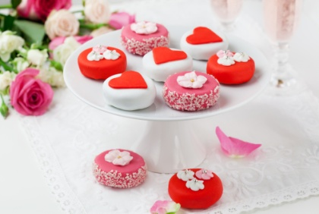
For example:
- Prepare isomalt and add required colour
- Take some isomalt granules and lay into a 4 sided tray
- Draw a shape in the granules, just like drawing in the sand
- Pour the cooling coloured isomalt into the grooves in the granulated isomalt
- Cover the cooling molten isomalt with more granulated isomalt
- Allow to cool completely
- When hardened remove from granules and wipe loose granules gently away from mould.
This can now be used as part of your display. Isomalt is better for this as it is very difficult to recrystallise and is more stable.
Other decorating mediums is the insertion of 'glitter' into the molten mass before it sets or scattering the glitter onto the oiled surface that is going to be used for the moulding.
Paint can be applied to sugar pieces after they have hardened
Food safe colours should only be used.

7.3 Display sugar work piece
Displaying the sugar work is a delicate procedure.
When the work has been assembled it needs to be carefully moved.
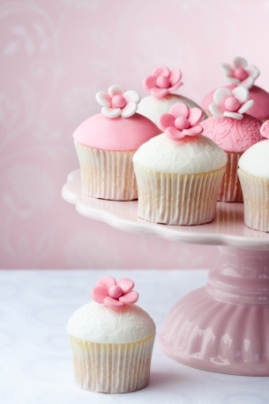
To move larger pieces it must be on a solid base:
- Ceramic
- Glass
- Mirrors
- Wood.
Any non impervious medium is acceptable as long it does not destroy the integrity of the sugar work display.
Any movement of pieces may require more than one person.
The base is the part that will be handled and it should be robust to handle any expected occurrences.
Display should be out of the reach of prying fingers. People will break them.
The structure of the display should be in a way that highlights the best of the model.
Will the base be stable? It is prudent to keep the sugar display as stable as possible because any movement can be an issue.
Once the display is set, leave it alone.

Work Projects
It is a requirement of this Unit you complete Work Projects as advised by your Trainer.
You must submit documentation, suitable evidence or other relevant proof of completion of the project to the date agreed with your Trainer.
Students will have to plan what they are going to produce.
Students will need to produce a model consisting of the following elements.
- Poured sugar cast piece:
- Three separate pieces that will be part of the final model
- Pulled and moulded sugar piece:
- Flowers, leaves and fruit models
- Moulded and blown elements.
To complete the model is all about planning. The students will need a work plan made of steps that will be required to produce the model.
For this section the student needs to show evidence of work actually being completed.
7.1 Assembling the display piece.
7.2. Decorate the assembled display piece.
7.3. Set piece up for display.

Summary

Assemble and display sugar work piece
Assemble sugar work
Assemble of sugar pieces is delicate and time consuming exercise
Breakages happen and nerves are tested
Have a plan.
Decorate sugar work piece
Decorating sugar pieces maybe placing other coloured sugar portions over base product; such as sugar basket; sugar fruit is an example of that decoration
Some practitioners will highlight edges with royal icing or the colour can be enhanced by applying other colours with a fine brush.
Display sugar work piece
Sugar work displays can be extravagant or very simple. Sugar may be opaque (cloudy) because it has been pulled or is can be clear (cast) and it has a light colouring
When the sugar piece has been placed onto stand it can have small lights to highlight the clarity or unique characteristic of the model.

Element 8:
Store sugar display pieces

8.1 Store according to enterprise and standard industry practice
Sugar work is temporary. This is due to several reasons:
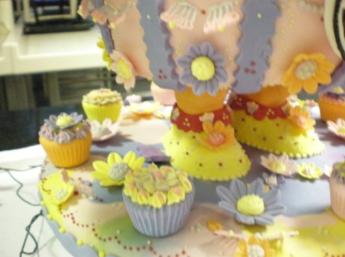
- Sugar is hydroscopic
- Sugar work is delicate and fragile.
Hydroscopic means moisture is drawn to it or it attracts moisture to itself.
The moisture from the air in the form of humidity will destroy any sugar model that has been produced unless it is protected.
Sugar work is stronger and will last longer when produced with isomalt. While isomalt is made from sugar it does not have the hydroscopic properties as sugar.
Sugar models can be stored in enclosed areas like a cupboard that can be well sealed and inside the cupboard silica crystals can be placed and changed as required.
Silica crystals have the ability of absorb moisture from the air so reducing the amount of moisture that goes to the sugar.

Sugar work fragility
When sugar is manipulated, shaped, cast or blown it cools and goes rock hard. When it is stretched to fine shapes it becomes delicate and fragile. More fragile than glass.
Many exhibits have been assembled and the slightest knock has caused it to collapse.
Any sugar work needs to be protected from rough handling, sudden bumps and the prying hands of inquisitive people who just want to touch to see if it is real or not.
Sugar exhibits need to be set well back from barricades or behind clear protection sheets.
Very few sugar pieces survive long term storage once they have been assembled.
At the beginning of the manual is a list of commodities that.

8.2 Store in appropriate conditions
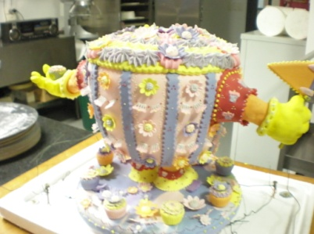
Sugar displays need to be kept well out of reach of prying hands and in an environment that is dry.
This is achieved by using drying agents in an enclosed area where display is being stored.
Sugar works are incredibly fragile so need to be kept out of the reach of people’s hands.
The public cannot help themselves.
Most will want to touch to see if it is REAL. Oops it has broken.
If you do not want this to happen then the display piece must be protected from prying hands.

8.3 Store to maintain maximum quality and appearance
Sugar displays can be sprayed with lacquers to protect against moisture in the air.
Store with silica gel sachets.
Minimal air movement.

Work Projects
It is a requirement of this Unit you complete Work Projects as advised by your Trainer.
You must submit documentation, suitable evidence or other relevant proof of completion of the project to the date agreed with your Trainer.
Students will have to plan what they are going to produce.
Students will need to produce a model consisting of the following elements:
- Poured sugar cast piece:
- Three separate pieces that will be part of the final model
- Pulled and moulded sugar piece:
- Flowers, leaves and fruit models
- Moulded and blown elements.
To complete the model is all about planning. The students will need a workplan made of steps that will be required to produce the model.
For this section the student needs to write a report as part of their overall assessment.
8.1 How does the sugar display piece need to be stored to maintain the quality of the finished product.
8.2 What conditions will need to be in place for the display to keep its optimum display attributes:
- Define your enterprise standard for storing the finished product.
8.3 What precaution will be taken to reduce humidity in the storage area.

Summary

Store sugar display pieces
Store according to enterprise and standard industry practice
Enterprise standard will vary
Many sugar displays have a limited life
Store all with silica gel sachets.
Store to maintain maximum quality and appearance
Store in appropriate conditions
Must be in humidity free environment
Dust free environment
Must be protected from damage.

Presentation of written work

1. Introduction
It is important for students to present carefully prepared written work. Written presentation in industry must be professional in appearance and accurate in content. If students develop good writing skills whilst studying, they are able to easily transfer those skills to the workplace.

2. Style

Students should write in a style that is simple and concise. Short sentences and paragraphs are easier to read and understand. It helps to write a plan and at least one draft of the written work so that the final product will be well organized. The points presented will then follow a logical sequence and be relevant. Students should frequently refer to the question asked, to keep ‘on track’. Teachers recognize and are critical of work that does not answer the question, or is ‘padded’ with irrelevant material. In summary, remember to:
- Plan ahead
- Be clear and concise
- Answer the question
- Proofread the final draft.

3. Presenting Written Work
Types of written work
Students may be asked to write:
- Short and long reports
- Essays
- Records of interviews
- Questionnaires
- Business letters
- Resumes.
Format
All written work should be presented on A4 paper, single-sided with a left-hand margin. If work is word-processed, one-and-a-half or double spacing should be used. Handwritten work must be legible and should also be well spaced to allow for ease of reading. New paragraphs should not be indented but should be separated by a space. Pages must be numbered. If headings are also to be numbered, students should use a logical and sequential system of numbering.
Cover Sheet
All written work should be submitted with a cover sheet stapled to the front that contains:
- The student’s name and student number
- The name of the class/unit
- The due date of the work
- The title of the work
- The teacher’s name
- A signed declaration that the work does not involve plagiarism.
Keeping a Copy
Students must keep a copy of the written work in case it is lost. This rarely happens but it can be disastrous if a copy has not been kept.
Inclusive language
This means language that includes every section of the population. For instance, if a student were to write ‘A nurse is responsible for the patients in her care at all times’ it would be implying that all nurses are female and would be excluding male nurses.
Examples of appropriate language are shown on the right:
Mankind | Humankind
Barman/maid | Bar attendant
Host/hostess | Host
Waiter/waitress | Waiter or waiting staff

Recommended reading
Bailey, Adrian & Ortiz, Elisabeth Lambert; 2003; The book of ingredients, Michael Joseph
Boyle, Peter; 1998; Sugar work: Blown-and pulled-sugar techniques; Van Nostrand Reinhold Co
Figoni, Paula; 2004; How baking works: Exploring the fundamentals of baking science;
John Wiley and Sons Inc
Greweling, Peter; 2012; Chocolates and Confections: Formula, Theory, and Technique for the Artisan Confectioner; Wiley
Hanneman, LJ; 1993 (2nd edition); Patisserie ; Butterworth Heinemann
Lodge, Nicholas; 1992; Cake Styling; Chancellor
Lodge, Nicholas; 1996; Pastillage and Sugar Moulding; Chancellor
Notter, Ewald; 2012; The Art of the Confectioner; Pastillage and Sugarwork; John Wiley and Sons
Notter, Ewald; 1987; Textbook of Sugar Pulling and Sugar Blowing; Candis-Verlag
Styler.Christopher; 2006; Working the Plate: The Art of Food Presentation; Houghton Mifflin Harcourt

Equipment that may be required
- Cooking stove or induction cooker
- Gas burner
- Microwave oven
- Basket weaving stand
- Blow torch
- Clamps for holding metal bars in position
- Gloves
- Hair dryer for heating and cooling sugar mass as required
- Cooling racks
- Cooling surfaces
- Silicon paper
- Plastic wrap
- Metal bars
- Stencils
- Knives for various roles
- Stainless steel bowls
- Plastic bottles with droppers
- Scissors, heavy duty and lightweight for fine work
- Metal moulds
- Rolling pins
- Rulers
- Scrapers, metal and plastic
- Templates
- Colours
- Thermometers
- Warming box heat resistant stirrers
- Fine strainers
- Sugar hand pump
- Titanium dioxide
- Scales
- Silicon inserts
- Silicon moulds

- Textured surfaces
- Aluminium foil
- Pot: good quality stainless steel or copper.

Trainee evaluation sheet

Prepare and display sugar work
The following statements are about the competency you have just completed.
Please tick the appropriate box | Agree | Don’t Know | Do Not Agree | Does Not Apply
There was too much in this competency to cover without rushing.
Most of the competency seemed relevant to me.
The competency was at the right level for me.
I got enough help from my trainer.
The amount of activities was sufficient.
The competency allowed me to use my own initiative.
My training was well-organized.
My trainer had time to answer my questions.
I understood how I was going to be assessed.
I was given enough time to practice.
My trainer feedback was useful.
Enough equipment was available and it worked well.
The activities were too hard for me.

The best things about this unit were:

The worst things about this unit were:

The things you should change in this unit are:

Trainee Self-Assessment Checklist
As an indicator to your Trainer/Assessor of your readiness for assessment in this unit please complete the following and hand to your Trainer/Assessor.

Prepare and display sugar work
 |  | Yes | No*
Element 1: Prepare sugar for boiling
1.1 | Select and weigh ingredients
1.2 | Combine ingredients and prepare sugar for boiling
1.3 | Collect equipment required to prepare sugar
Element 2: Boil sugar
2.1 | Collect equipment required to boil sugar
2.2 | Follow specified method of sugar boiling
2.3 | Use colours appropriately
2.4 | Handle boiled sugar solution safely
Element 3: Pull boiled sugar
3.1 | Collect equipment required to pull boiled sugar
3.2 | Manipulate boiled sugar
3.3 | Store/hold pulled sugar
Element 4: Use pulled sugar to produce display sugar work
4.1 | Collect equipment required to produce display sugar pieces
4.2 | Produce blown sugar shapes
4.3 | Produce ribbons and bows
4.4 | Shape sugar pieces into leaves and flowers
4.5 | Weave sugar to form baskets
Element 5: Pour boiled sugar to produce cast display sugar work
5.1 | Collect equipment required to produce cast display sugar work pieces
5.2 | Add specific ingredients to create effects
5.3 | Pour and set sugar
5.4 | Release sugar from forms
Element 6: Plan sugar display piece
6.1 | Plan display piece appropriate to client, occasion or theme able to be produced in time available using a variety of techniques
6.2 | Prepare a sketch or outline of display
6.3 | Prepare forms and shapes as required by the design
6.4 | Calculate quantities required for components of display piece
Element 7: Assemble and display sugar work piece
7.1 | Assemble sugar work
7.2 | Decorate sugar work piece
7.3 | Display sugar work piece
Element 8: Store sugar display pieces
8.1 | Store according to enterprise and standard industry practice
8.2 | Store in appropriate conditions
8.3 | Store to maintain maximum quality and appearance

Statement by Trainee:
I believe I am ready to be assessed on the following as indicated above:
Signed: | _____________________________ | Date: | ______ / ______ / ______
Note:
For all boxes where a No* is ticked, please provide details of the extra steps or work you need to do to become ready for assessment.





